UNIVERSITY OF BOTSWANA
FACULTY OF SCIENCE
DEPARTMENT OF COMPUTER SCIENCE
DETAILED PROJECT PROPOSAL
QuickConnect: A Location-Based Marketplace Platform for Local Service Providers in Botswana
Submitted by:
Webster Maunge
Student ID: 202103578
Degree: Bachelor of Science in Computer Science
Supervisor: Dr Diallo
Academic Year: 2025/2026

CERTIFICATION
I certify that this proposal is my own work and has been written by me. Any assistance received has been acknowledged, and all sources consulted have been cited appropriately.

Student Name: Webster Maunge
Student ID: 202103578
Programme: Bachelor of Science in Computer Science
Supervisor: Dr Diallo
Academic Year: 2025/2026

Signature: ________________________________
Date: ________________________________

Supervisor Declaration
I confirm that I have supervised this student's project and that the work described is original and satisfactory for submission.

Supervisor Signature: ________________________________
Date: ________________________________

ACKNOWLEDGEMENTS
I would like to express my sincere gratitude to Dr Diallo, my project supervisor, for the consistent guidance, constructive feedback, and encouragement provided throughout the development of this project. His technical expertise and patience have been invaluable in shaping both the system architecture and the academic rigour of this proposal.

I am also grateful to the Department of Computer Science at the University of Botswana for providing the academic framework and resources that made this project possible. The open-source communities behind React, Supabase, TypeScript, and Tailwind CSS deserve recognition for creating the powerful tools that underpin this platform.

Finally, I am thankful to my family and friends for their unwavering support and understanding during the demanding periods of this project.

ABSTRACT
QuickConnect is a location-based marketplace platform designed to bridge the gap between customers seeking informal-sector services and service providers in Botswana. The platform addresses a significant market inefficiency — the reliance on unstructured social media channels and word-of-mouth for service discovery — by offering a structured, trust-enabled digital alternative.

The system is built using a modern Jamstack architecture: a React 19 TypeScript frontend served via Vite 7, and Supabase (PostgreSQL 15 with PostGIS, GoTrue authentication, PostgREST, Realtime WebSockets, and Storage) as the backend-as-a-service layer. Key features delivered include role-based user management, real-time messaging, a secure escrow-based wallet payment system with mobile money integration scaffolding, a quote-and-booking lifecycle, a rating and review system, provider portfolio management, and a platform administrator dashboard. The application is deployed as a Progressive Web App (PWA), ensuring offline capability and mobile-first performance.

Security is enforced at the database level through Row Level Security (RLS) policies and SECURITY DEFINER stored procedures that guarantee atomic and tamper-proof financial transactions. A comprehensive testing strategy validated the system against twelve defined project objectives. Nine objectives were fully achieved; three were partially achieved due to external dependency constraints.

Keywords: marketplace platform, location-based services, Botswana, informal sector, React, Supabase, PostgreSQL, Row Level Security, Progressive Web App, mobile money.

Table Of Contents
CERTIFICATION 2
ACKNOWLEDGEMENTS 3
ABSTRACT 4
CHAPTER 1: INTRODUCTION 11
1.1 Problem Statement 11
1.1.1 Current State of Service Discovery 11
1.1.2 Challenges for Customers 11
1.1.3 Challenges for Service Providers 12
1.1.4 Market Gap Analysis 13
1.2 Motivation 13
1.2.1 Digital Infrastructure Readiness 13
1.2.2 Demonstrated Market Need 13
1.2.3 Economic Impact Potential 14
1.2.4 Technical Feasibility 14
1.2.5 Innovation Opportunity 14
1.3 Proposed Solution 15
1.3.1 Platform Architecture Overview 15
1.3.2 Core Innovation: The "Looking For" Feature 15
1.3.3 Key Features for Customers 15
1.3.4 Key Features for Service Providers 16
1.3.5 Technology Stack Details 17
1.4 Project Objectives 17
1.4.1 Main Objective 17
1.4.2 Specific Objectives 17
1.5 Project Scope 18
1.5.1 In Scope (MVP - By April 2026) 18
1.5.2 Out of Scope (Future Enhancements) 20
1.6 Project Schedule 21
CHAPTER 2: LITERATURE REVIEW 21
2.1 International Platform Analysis 22
2.1.1 TaskRabbit (United States) 22
2.1.2 Thumbtack (United States) 22
2.1.3 Urban Company (India) 22
2.2 African Context Platforms 23
2.2.1 Lynk (Kenya) 23
2.2.2 Success Factors for African Platforms 23
2.3 Local Botswana Context 24
2.3.1 Current Market Landscape 24
2.3.2 Market Research Findings 24
2.3.3 Digital Infrastructure Assessment 25
2.4 Technology Review 25
2.4.1 Frontend Technologies 25
2.4.2 Backend Technology 26
2.4.3 Mapping and Location Services 27
2.5 Research Gap 27
CHAPTER 3: REQUIREMENTS ANALYSIS 28
3.1 Development Methodology 28
3.1.1 Agile Approach Justification 28
3.1.2 Sprint Structure 28
3.2 Requirements Analysis (Pre-Proposal) 28
3.2.1 Data Collection Methods 28
3.2.2 Requirements Documentation 29
3.2.3 Functional Requirements 29
3.2.4 Non-Functional Requirements 31
3.2.5 Usability Requirements 32
3.2.6 Security Requirements 33
3.3 Dynamic Model Specification 35
3.3.1 Use Case Diagram 36
3.3.2 Data Flow Diagram (Level 0 — Context Diagram) 36
3.3.3 State Transition Diagram — Booking Lifecycle 37
CHAPTER 4: SYSTEM DESIGN SPECIFICATION 39
4.1 System Architecture 39
4.1.1 Client Layer 39
4.1.2 Application Layer 39
4.1.3 Backend-as-a-Service Layer 39
4.1.4 Architecture Diagram 39
4.2 Database Design Specification 40
4.2.1 Core Tables 40
4.2.2 Entity Relationship Diagram 42
4.2.3 Database Triggers and SECURITY DEFINER Functions 43
4.2.4 Row Level Security Strategy 43
4.3 Interface Design Specification 44
4.3.1 Design Principles 44
4.3.2 Layout System 44
4.3.3 Colour Palette and Typography 44
4.3.4 Key Screen Designs 44
4.3.5 Interface Wireframes 45
4.4 Functional Design Specification 55
4.4.1 Component Architecture 55
4.4.2 State Management Strategy 55
4.4.3 Wallet Escrow Payment Flow 55
4.4.4 "Looking For" Provider Matching 56
4.4.5 Authentication and Session Design 56
4.5 Security Design Specification 57
CHAPTER 5: IMPLEMENTATION AND TESTING 58
5.1 Implementation Environment 58
5.1.1 Hardware 58
5.1.2 Software and Tools 58
5.2 Implementation Details 58
5.2.1 Database Schema Implementation 58
5.2.2 Authentication Module 59
5.2.3 "Looking For" Feature Implementation 59
5.2.4 Wallet and Escrow Payment Module 59
5.2.5 Real-time Messaging Module 60
5.2.6 Notification System 60
5.2.7 Admin Module 60
5.2.8 Progressive Web App Configuration 60
5.3 System Testing 60
5.3.1 Testing Approach 60
5.3.2 Functional Test Cases and Results 61
5.3.3 Non-Functional Testing 62
5.3.4 User Acceptance Testing 62
5.4 System Evaluation 63
5.4.1 Achievement of Objectives 63
5.4.2 Strengths of the Implementation 63
5.4.3 Limitations and Future Work 64
5.4.4 What I Learned 65
CHAPTER 6: CONCLUSION 68
6.1 Summary 68
6.2 Conclusions 68
6.3 Future Work 68
REFERENCES 69
APPENDIX A: USER MANUAL 73
A.1 Introduction 73
A.2 System Requirements 73
A.3 Installation and Setup 73
A.4 Operational Usage Guide 74
A.5 Wallet and Payments 75
A.6 Troubleshooting 75
APPENDIX B: SOURCE CODE SUMMARY 77
B.1 Repository Structure 77
B.2 Modular Architecture 77
B.3 Programming Style and Conventions 78
B.4 Database Schema Summary 79
B.5 Build and Deployment 79

LIST OF TABLES

Table 1.1: Project Phase Summary 12
Table 3.1: Functional Requirements 17
Table 3.2: Non-Functional Requirements 19
Table 3.3: Usability Requirements 20
Table 3.4: Security Requirements 21
Table 4.1: Core Database Tables 28
Table 4.2: Database Triggers and SECURITY DEFINER Functions 31
Table 4.3: Layered Security Design Specification 40
Table 4.4: Colour Palette and Typography 33
Table 4.5: Key Screen Designs 34
Table 5.1: Hardware Implementation Environment 42
Table 5.2: Software and Tools 43
Table 5.3: Database Schema Migrations Summary 44
Table 5.4: Functional Test Cases and Results 50
Table 5.5: User Acceptance Testing Results 54
Table 5.6: Achievement of Project Objectives 55

LIST OF FIGURES

Figure 3.1: QuickConnect Use Case Diagram 23
Figure 3.2: QuickConnect Data Flow Diagram (Context Level) 24
Figure 3.3: Booking Lifecycle State Transition Diagram 25
Figure 1.1: QuickConnect Project Gantt Chart 12
Figure 4.1: QuickConnect System Architecture 27
Figure 4.2: QuickConnect Entity Relationship Diagram 30
Figure 4.3: QuickConnect Frontend Component Diagram 36
Figure 4.4: Wallet Escrow Payment Sequence Diagram 37
Figure 4.5: WF-1: Home / Landing Page 46
Figure 4.6: WF-2: Register / Sign Up 47
Figure 4.7: WF-3: Create "Looking For" Post 48
Figure 4.8: WF-4: Provider Search Results 49
Figure 4.9: WF-5: Provider Profile 50
Figure 4.10: WF-6: My Bookings (Customer View) 51
Figure 4.11: WF-7: Wallet 52
Figure 4.12: WF-8: Real-time Messaging (Chat) 53
Figure 4.13: WF-9: Provider Dashboard 54

CHAPTER 1: INTRODUCTION
In the contemporary digital landscape, marketplace platforms have revolutionized how services are discovered, booked, and delivered across the globe. From TaskRabbit in the United States to Urban Company in India, these platforms have demonstrated the transformative potential of connecting service providers directly with customers through technology. However, Botswana, despite its remarkable digital infrastructure development and high mobile penetration rates, lacks a comprehensive digital solution that addresses the unique needs of its local service economy.

QuickConnect emerges as a response to this gap a location based marketplace platform specifically designed for the Botswana context. The platform aims to bridge the disconnect between local service providers and customers by leveraging modern web and mobile technologies, integrated payment solutions, and an innovative approach to service discovery through its flagship "Looking For" feature.

This detailed project proposal outlines the comprehensive plan for designing, developing, and deploying QuickConnect as a final year capstone project. The document presents the problem context, proposed solution, methodology, technical architecture, and implementation timeline for creating a fully functional marketplace platform that serves the needs of Botswana's service economy.

1.1 Problem Statement
Botswana currently lacks a comprehensive digital platform that effectively connects local service providers with customers. The existing landscape is characterized by fragmented, informal methods that create significant barriers for both parties in the service marketplace ecosystem.

1.1.1 Current State of Service Discovery
The primary methods currently used for service discovery in Botswana include social media platforms (primarily Facebook groups and WhatsApp networks), word-of-mouth referrals through personal and professional networks, classified advertisements in newspapers and online portals, and informal business directories with limited reach and outdated information. These methods, while functional, present numerous challenges that hinder efficient service marketplace operations.

1.1.2 Challenges for Customers
Customers face multiple obstacles when seeking services through current channels:
- Absence of standardized verification systems to confirm provider credentials, qualifications, or reliability before engagement
- Time intensive search processes that require monitoring multiple platforms, groups, and networks simultaneously
- Lack of transparent pricing mechanisms that would enable informed comparison between providers
- No centralized review or rating systems to assess service quality based on previous customer experiences
- Predominantly cash based transactions with no digital records for accountability or dispute resolution
- Difficulty in communicating service requirements clearly without standardized formats
- No mechanism for tracking service delivery progress or booking status
- Limited recourse options when service quality falls below expectations

1.1.3 Challenges for Service Providers
Service providers encounter equally significant barriers in the current ecosystem:
- Market reach limited to personal networks and social media following, restricting growth potential
- Unpredictable customer acquisition leading to inconsistent income and difficulty in business planning
- Significant time investment (estimated 5+ hours weekly) required for marketing across multiple platforms
- No centralized platform to build, showcase, and grow professional reputation systematically
- Geographical constraints making expansion to other areas in Botswana challenging
- Difficulty in managing bookings, schedules, and customer communications efficiently
- No formal mechanism to receive and display customer testimonials and reviews
- Limited ability to showcase portfolios, qualifications, and service offerings professionally

1.1.4 Market Gap Analysis
Despite Botswana's favorable digital infrastructure conditions, including 72% internet penetration, 67% smartphone adoption, and widespread mobile money usage (Orange Money, BTC MyZaka, Mascom MyZaka) with transactions exceeding P50 billion in 2023, no platform currently addresses this market gap with locally-integrated payment options and Botswana specific features. This represents a significant opportunity for technological intervention that could transform the local service economy.

1.2 Motivation
The development of QuickConnect is motivated by several compelling factors that indicate both the feasibility and potential impact of such a platform in the Botswana context.

1.2.1 Digital Infrastructure Readiness
Botswana has achieved remarkable progress in digital infrastructure development, creating an ideal environment for digital marketplace adoption. The country's 72% internet penetration rate provides a substantial connected population base. Smartphone adoption at 67% ensures that both providers and customers have access to the necessary devices. Mobile money services have achieved significant penetration, with transactions exceeding P50 billion in 2023, demonstrating comfort with digital payments. Additionally, the government's commitment to digital transformation through initiatives like the SmartBots strategy creates a supportive policy environment.

1.2.2 Demonstrated Market Need
Evidence of market demand is clearly visible in existing digital behaviors:
- Facebook groups dedicated to local services, such as "Gaborone Services," have accumulated 45,000+ members
- Hundreds of daily service requests are posted across various social media platforms
- Preliminary research indicates 87% of customers struggle to find reliable service providers
- 93% of service providers identify customer acquisition as their primary business challenge
- 80% of providers report spending over 5 hours weekly on marketing activities
- All surveyed respondents own smartphones and actively use mobile money services

1.2.3 Economic Impact Potential
The platform has potential to generate significant economic benefits across multiple dimensions. Formalization of the informal service sector, which constitutes approximately 30% of Botswana's economy, can improve economic efficiency. Service providers can experience increased income through expanded market access and reduced customer acquisition costs. Customers benefit from reduced search costs and better service matching. The platform can contribute to tax revenue generation through formalized digital transactions. Additionally, improved service delivery standards can enhance overall economic productivity.

1.2.4 Technical Feasibility
Modern development tools and platforms make the development of QuickConnect technically feasible within the constraints of the capstone project timeline. React.js provides a robust framework for web application development with extensive community support. Flutter enables cross-platform mobile application development with native performance. Supabase offers a comprehensive backend-as-a-service solution with database, authentication, real-time capabilities, and storage. Free tiers of cloud services enable development and initial deployment without significant financial investment.

1.2.5 Innovation Opportunity
The "Looking For" feature represents a significant innovation in marketplace design. Traditional marketplaces follow a provider centric model where customers search through provider listings. QuickConnect inverts this paradigm by enabling customers to post their service needs, after which relevant providers can respond with competitive quotes. This customer-centric approach addresses several pain points: customers no longer need to identify and contact multiple providers individually, providers receive qualified leads directly, and the competitive quote system promotes price transparency and service quality.

1.3 Proposed Solution
QuickConnect is designed as a comprehensive web and mobile marketplace platform with three integrated technology components working in concert to deliver a seamless user experience.

1.3.1 Platform Architecture Overview
The platform comprises three main technical components:
- Web Application: Built with React.js, TypeScript, and Tailwind CSS for responsive, modern user interfaces
- Mobile Application: Developed using Flutter for cross-platform iOS and Android deployment
- Backend Infrastructure: Powered by Supabase, providing PostgreSQL database, REST API, real-time subscriptions, authentication, and file storage.

1.3.2 Core Innovation: The "Looking For" Feature
The "Looking For" feature fundamentally changes how customers and providers interact in the marketplace. In the traditional marketplace model, customers follow a linear path: Search for services, filter results, browse provider profiles, contact selected providers, negotiate terms, and finally book services. This process is time-consuming and places the burden of discovery entirely on the customer.

QuickConnect's "Looking For" feature inverts this workflow: Customers post their service needs with descriptions, budgets, and timelines. The system notifies relevant providers based on service category and location. Interested providers respond with personalized quotes and messages. Customers review responses and select the best offer. The booking is confirmed and tracked through completion. This approach reduces customer effort while ensuring providers receive qualified, relevant opportunities.

1.3.3 Key Features for Customers
The platform offers comprehensive features designed for customer needs:
- Looking For Posts: Create service requests with natural language descriptions, categories, budgets, preferred dates, and urgency levels
- Competitive Quotes: Receive and compare multiple provider’s offers in a standardized format
- Provider Discovery: Browse provider profiles with ratings, reviews, portfolios, and service offerings
- Real-time Messaging: Communicate directly with providers through Supabase-powered instant messaging
- Booking Management: Create bookings, track status through completion, and manage service history
- Integrated Payments: Pay via Orange Money, BTC MyZaka, or Mascom MyZaka through secure integration
- Review System: Leave ratings and written reviews after service completion to build community trust
- Location Services: Find nearby providers using GPS and Google Maps integration

1.3.4 Key Features for Service Providers
Service providers benefit from a comprehensive suite of professional tools:
- Professional Profiles: Create detailed business profiles with descriptions, service offerings, pricing, and photo galleries
- Opportunity Feed: View relevant "Looking For" posts filtered by service category and location
- Quote Submission: Respond to customer requests with customized quotes and personalized messages
- Booking Calendar: Manage scheduled services, set availability, and track upcoming appointments
- Earnings Dashboard: Track income, payment history, and financial performance
- Reputation Building: Accumulate reviews and ratings to build professional credibility
- Service Area Management: Define and update geographical service coverage areas
- Portfolio Showcase: Upload images demonstrating previous work quality

1.3.5 Technology Stack Details
The technical implementation leverages modern, proven technologies:
- Web Frontend: React 18 with TypeScript for type safety, Tailwind CSS for styling, React Router for navigation, React Query for server state management.
- Mobile Frontend: Flutter SDK with Dart language, provider pattern for state management, flutter_bloc for complex state scenarios.
- Backend: Supabase (PostgreSQL with PostGIS extension for geospatial queries, PostgREST for auto-generated REST API, Realtime for WebSocket subscriptions, GoTrue for authentication, Storage for file management).
- External Integrations: Google Maps Platform for mapping and geocoding, Mobile Money APIs (Orange Money, BTC MyZaka, Mascom MyZaka) for payments.

1.4 Project Objectives

1.4.1 Main Objective
Design, develop, and deploy a location-based marketplace platform that connects service providers with customers across Botswana through an innovative "Looking For" feature, real-time communication capabilities, and integrated mobile money payment solutions.

1.4.2 Specific Objectives
The project aims to achieve the following specific, measurable objectives:
- Develop a comprehensive user management system with secure authentication supporting dual roles (customer and provider) using Supabase Auth
- Implement the "Looking For" feature with intelligent provider matching algorithm based on service category and geographical location
- Build location-based service discovery functionality with Google Maps integration for provider search and service area visualization
- Create a comprehensive booking management system with full lifecycle status tracking from request to completion
- Integrate local mobile money payment methods (Orange Money, BTC MyZaka, Mascom MyZaka) or implement simulation mode if APIs are unavailable
- Build a real-time messaging system using Supabase Realtime for instant communication between customers and providers
- Implement a rating and review system linked to completed bookings to build platform trust and accountability
- Develop a responsive web application using React.js with TypeScript and a native mobile application using Flutter
- Implement comprehensive security measures including Row Level Security (RLS) policies and JWT-based authentication
- Create an administrative dashboard for platform management, user oversight, and analytics
- Conduct comprehensive testing including unit tests, integration tests, end-to-end tests, and user acceptance testing with 10-15 participants
- Deploy the platform to production environments (GitHub Pages for web, Supabase Cloud for backend) with proper documentation

1.5 Project Scope

1.5.1 In Scope (MVP - By April 2026)
The following features and deliverables are included in the Minimum Viable Product scope:
User Management and Authentication:
- User registration with email verification
- Login with email/password and social authentication options
- Password reset functionality
- Profile management for both customers and service providers
- Role-based access control
Service Provider Features:
- Comprehensive business profile creation and management
- Service listings with categories, descriptions, and pricing
- Portfolio image gallery
- Service area definition (Gaborone, Francistown, Maun initially)
- Availability calendar management
Customer Features:
- "Looking For" post creation with detailed service requirements
- Provider search and filtering by category and location
- Provider profile viewing with ratings and reviews
- Quote comparison and selection
Transaction Features:
- Booking creation and status management
- Real-time messaging between parties
- Payment recording (with simulation mode if APIs unavailable)
- Rating and review submission after completion
Technical Deliverables:
- Responsive web application (React + TypeScript)
- Mobile application for Android (Flutter), iOS optional
- RESTful API through Supabase
- PostgreSQL database with PostGIS
- Google Maps integration
- Basic admin dashboard
- Comprehensive testing suite
- User and technical documentation

1.5.2 Out of Scope (Future Enhancements)
The following features are explicitly excluded from the MVP but designed for future implementation:
- Live mobile money API integration (if production APIs unavailable during development)
- Advanced messaging features (typing indicators, read receipts, voice/video calls)
- Multi-language support (English/Setswana localization)
- AI-powered service recommendations and matching
- Provider verification system (ID verification, background checks)
- Insurance integration for service protection
- Expansion to all Botswana towns (architecture supports future expansion)
- Advanced analytics dashboard for providers
- Subscription-based provider premium features
Subscription revenue allocation (planned): a portion of provider subscription fees may fund a ring-fenced pool to compensate providers when customers default on payment or when full recovery through in-app wallet debits is not achievable, subject to eligibility rules, caps, and audit—complementing, not replacing, ledger-based settlement.
- Dispute resolution system with mediation

1.6 Project Schedule
The project was executed over two academic semesters (October 2025 – April 2026) following the University of Botswana milestone framework. Table 1.1 summarises the phase allocation and Figure 1.1 provides the corresponding Gantt chart.

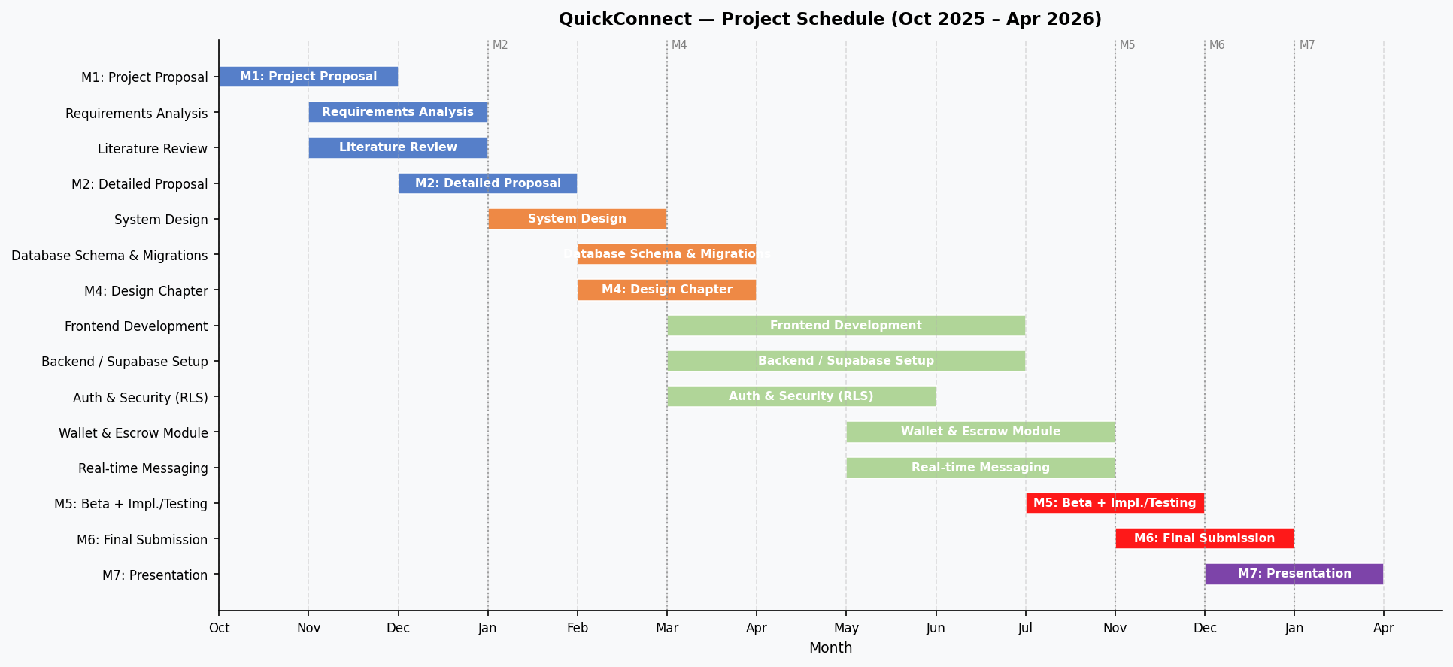
Figure 1.1: QuickConnect Project Gantt Chart

Table 1.1: Project Phase Summary
Phase | Period | Key Deliverables
Initiation & Proposal | Oct – Nov 2025 | Project proposal, requirements, literature review
Design | Nov – Jan 2026 | System architecture, ER diagram, wireframes
Implementation (Sprint 1) | Jan – Feb 2026 | Auth, roles, provider profiles, booking lifecycle
Implementation (Sprint 2) | Feb – Mar 2026 | Wallet/escrow, messaging, reviews, admin dashboard
Testing & QA | Mar – Apr 2026 | Functional tests, UAT, performance profiling
Final Submission | Apr 2026 | Complete proposal, source code, user manual
Table 1.1: Project Phase Summary

CHAPTER 2: LITERATURE REVIEW
This chapter presents a comprehensive review of existing literature and platforms related to service marketplaces, examining international platforms, African context solutions, local Botswana conditions, and relevant technology frameworks. The review establishes the theoretical foundation and identifies the research gap that QuickConnect addresses.

2.1 International Platform Analysis

2.1.1 TaskRabbit (United States)
TaskRabbit, founded in 2008 and acquired by IKEA in 2017, pioneered the on-demand task services model in the United States. The platform connects "Taskers" (service providers) with customers needing help with everyday tasks including furniture assembly, moving assistance, handyman services, and cleaning.
Key features of TaskRabbit include background-checked workers providing trust assurance, flexible pricing models allowing providers to set rates, task-based matching algorithms, integrated payment processing, and review systems for quality assurance. The platform demonstrates marketplace viability but presents limitations for Botswana adaptation: reliance on credit card payments unsuitable for markets with lower credit card penetration, infrastructure assumptions around reliable addresses and mapping, and pricing models designed for higher-income markets.

2.1.2 Thumbtack (United States)
Thumbtack operates a quote-based marketplace model where customers describe their project needs and receive bids from professionals. This approach shares conceptual similarities with QuickConnect's "Looking For" feature. The platform covers diverse service categories including home improvement, events, lessons, and wellness services.

Thumbtack's key innovations include project-based matching where customers describe needs and receive targeted responses, professional profiles with portfolios and credentials, price transparency through competitive bidding, and category-specific questionnaires for detailed requirement capture. However, Thumbtack's pay-per-lead model, where providers pay to contact customers, may be unsuitable for smaller markets with lower transaction volumes.

2.1.3 Urban Company (India)
Urban Company (formerly UrbanClap), founded in 2014 and operating across 40+ Indian cities with over 20 million customers, provides the most relevant comparison for QuickConnect. Operating in a developing market context like Botswana, Urban Company demonstrates that service marketplaces can thrive in emerging economies.

Urban Company's success factors include mobile-first design prioritizing smartphone users, integration with local payment methods (UPI, Paytm, and other mobile wallets), professional training programs ensuring service quality, standardized pricing removing negotiation friction, and city-by-city expansion strategy allowing localized operations. The platform's success in India's diverse market conditions provides evidence for QuickConnect's potential in Botswana's similar, though smaller-scale, context.

2.2 African Context Platforms

2.2.1 Lynk (Kenya)
Lynk, founded in 2015 in Nairobi, Kenya, connects informal sector workers (locally called "fundis") with customers. The platform has achieved significant scale with over 60,000 registered workers and 500,000+ completed jobs, proving African marketplace viability.
Lynk's evolution provides valuable lessons: the platform started with SMS-based interaction before evolving to mobile applications, recognizing infrastructure constraints; M-Pesa integration was non-negotiable for market adoption; simplified user experience accommodates varying digital literacy levels; and worker training programs improve service quality while providing livelihood opportunities. Lynk's success demonstrates that African markets can support technology-enabled service marketplaces when designed with local context in mind.

2.2.2 Success Factors for African Platforms
Analysis of successful African digital platforms reveals critical success factors:
- Mobile Money Integration: Non-negotiable for markets with low credit card penetration. M-Pesa in Kenya, MTN Mobile Money in West Africa, and similar services have become primary payment methods.
- Mobile-First Design: With smartphone access exceeding computer access in most African markets, mobile-optimized experiences are essential rather than optional.
- Simplified User Experience: Accommodating varying digital literacy levels through intuitive interfaces, minimal text input requirements, and visual navigation.
- Trust-Building Mechanisms: In markets with limited formal verification systems, platform-based trust through reviews, ratings, and transaction history becomes crucial.
- Localized Approach: Understanding local service categories, pricing expectations, and cultural factors in service delivery.

2.3 Local Botswana Context

2.3.1 Current Market Landscape
Botswana's service marketplace currently operates through informal channels without dedicated digital infrastructure. No direct competitors exist in the local market, creating a significant first-mover opportunity for QuickConnect.
Current informal solutions include:
- Facebook Groups: Groups like "Gaborone Services" have accumulated 45,000+ members, demonstrating demand for service discovery. However, these groups lack verification, payment integration, and booking management.
- WhatsApp Networks: Personal and community WhatsApp groups facilitate referrals but remain limited to existing social networks without public discoverability.
- Word-of-Mouth: Traditional referral networks remain the primary discovery method but limit market reach and growth potential for providers.
- Classified Advertisements: Newspaper and online classified ads provide limited reach with no interaction or transaction capabilities.

2.3.2 Market Research Findings
Preliminary market research conducted with 30 customers and 15 service providers in Gaborone revealed significant insights:
Customer Pain Points:
- 87% of customers reported difficulty finding reliable service providers
- 82% expressed desire for review systems before hiring providers
- 76% indicated frustration with inconsistent pricing across providers
- 91% have smartphones and actively use social media
- 100% of respondents use mobile money services
Service Provider Challenges:
- 93% identified customer acquisition as their biggest business challenge
- 80% spend more than 5 hours weekly on marketing activities
- 73% expressed desire for a centralized platform to showcase services
- 87% indicated willingness to pay reasonable commissions for qualified leads
- 100% own smartphones and use mobile money

2.3.3 Digital Infrastructure Assessment
Botswana's digital infrastructure presents favorable conditions for marketplace deployment:
- Internet Penetration: 72% of the population has internet access, primarily through mobile connections
- Smartphone Adoption: 67% smartphone penetration provides the device infrastructure for mobile app usage
- Mobile Money: Three major providers (Orange Money, BTC MyZaka, Mascom MyZaka) with combined transaction volume exceeding P50 billion annually
- Network Coverage: 3G/4G coverage across urban areas and major towns including Gaborone, Francistown, and Maun
- Government Support: SmartBots digital transformation strategy supports technology adoption

2.4 Technology Review

2.4.1 Frontend Technologies
React.js Selection Rationale:
React.js, developed by Facebook and released in 2013, has become the leading frontend JavaScript library. Research by Aggarwal (2018) demonstrates that React's component-based architecture and Virtual DOM implementation provide 30-40% performance improvements compared to traditional DOM manipulation frameworks.

Key React advantages for QuickConnect include declarative programming model simplifying UI development, component reusability reducing development time, extensive ecosystem with mature libraries for routing, state management, and API integration, strong TypeScript support enhancing code quality and maintainability, and large community providing documentation, tutorials, and support resources.

Flutter Selection Rationale:
Flutter, developed by Google and released in 2017, enables cross-platform mobile development from a single codebase. Research by Hansson and Vidhall (2016) on cross-platform frameworks demonstrates Flutter's advantages in development efficiency.

Flutter benefits for QuickConnect include 95%+ code reusability between iOS and Android platforms, native performance through direct compilation to ARM code, rich widget library providing consistent Material Design implementation, hot reload enabling rapid development iteration, and single codebase reducing timeline feasibility concerns.

2.4.2 Backend Technology
Supabase Selection Rationale:
Supabase, an open-source Firebase alternative, provides a comprehensive backend-as-a-service platform built on PostgreSQL. For a capstone project with limited development time, Supabase offers significant productivity advantages.

Supabase capabilities include PostgreSQL database with full SQL capabilities and PostGIS extension for geospatial queries, auto-generated REST API through PostgREST reducing backend development time, built-in authentication with multiple providers and JWT tokens, real-time subscriptions via WebSocket for instant messaging and updates, file storage with CDN delivery for images and documents, and Row Level Security (RLS) for data access control at database level.

Supabase's feature set can save an estimated 4-7 weeks of development time compared to building equivalent functionality with custom backend frameworks.

2.4.3 Mapping and Location Services
Google Maps Platform provides comprehensive mapping services with reliable coverage in Botswana. The platform's $200 monthly free credit covers typical development and initial deployment usage. Key capabilities include Maps JavaScript API for web embedding, Places API for location search and autocomplete, Geocoding API for address-to-coordinate conversion, and Distance Matrix API for travel time calculations.

2.5 Research Gap
The literature review reveals a significant research and market gap that QuickConnect addresses:
- No existing platform specifically targets Botswana's service marketplace with local payment integration and Botswana-specific features
- Limited academic research exists on marketplace platform design for smaller African markets with lower population density
- The "Looking For" customer-centric approach represents an innovation not widely implemented in African marketplace contexts
- Existing international platforms are not designed for local currency, local payment methods, or local service categories
- No platform combines service marketplace functionality with comprehensive mobile money integration for the Botswana market

QuickConnect addresses this gap by adapting proven marketplace models to local conditions while introducing the innovative "Looking For" feature that better serves both customers and providers in the Botswana context.

CHAPTER 3: REQUIREMENTS ANALYSIS
This chapter presents the comprehensive requirements analysis for QuickConnect, including the development methodology, data collection methods, and detailed functional, non-functional, usability, and security requirements. The system design, implementation, testing, and deployment phases will be documented in subsequent versions of this proposal as per the university milestone schedule.

3.1 Development Methodology
The project adopts Agile Software Development principles, specifically adapted for individual developer context while maintaining core agile values of iterative development, continuous feedback, and adaptive planning.

3.1.1 Agile Approach Justification
Agile methodology is selected for several reasons: iterative development enables early detection and correction of issues, 2-week sprints provide regular checkpoints for progress assessment, flexibility accommodates changing requirements or technical discoveries; emphasis on working software aligns with capstone project deliverables, and continuous integration practices ensure system stability throughout development.

3.1.2 Sprint Structure
Each 2-week sprint follows a consistent structure, Sprint Planning (Day 1) defines sprint goals and backlog items, Daily Progress tracking monitors advancement, Development Work (Days 2-13) implements planned features, Testing (ongoing) validates completed work, and Sprint Review (Day 14) evaluates deliverables and plans next sprint.

3.2 Requirements Analysis (Pre-Proposal)

3.2.1 Data Collection Methods
Online Survey:
A structured online survey using Google Forms will collect quantitative data from 10-30 respondents, comprising 20-30 potential customers and 3-10 service providers. Distribution channels include university student groups, Botswana-focused Facebook communities, and WhatsApp networks. Survey topics cover current service discovery methods, pain points in existing processes, technology readiness and preferences, desired platform features, and payment method preferences.

Semi-Structured Interviews:
Qualitative data will be gathered through 3-10 semi-structured interviews with service providers in Gaborone. Each interview, lasting 10-30 minutes and audio-recorded with consent, will explore current business processes and customer acquisition methods, challenges faced in service delivery, technology usage patterns, feedback on proposed platform features, and pricing and commission expectations. Thematic analysis will identify patterns, and findings will inform user persona creation.

Competitive Analysis:
Systematic analysis of existing solutions will document features, limitations, and best practices from Facebook groups used for service discovery, WhatsApp Business implementations, international platforms (TaskRabbit, Thumbtack, Urban Company), and African platforms (Lynk, similar regional solutions).

Technical Feasibility Assessment:
Technical prototyping will validate technology choices by testing Supabase capabilities (database operations, RLS policies, real-time subscriptions, geospatial queries), Flutter integration (Google Maps, Supabase SDK, device testing), mobile money API availability and documentation, and third-party service limitations and costs.

3.2.2 Requirements Documentation
Requirements will be documented using industry-standard formats including functional requirements specification, non-functional requirements specification, use case diagrams and descriptions, and MoSCoW prioritization (Must Have, Should Have, Could Have, Won't Have).

3.2.3 Functional Requirements
Table 3.1 presents the functional requirements organized by category:
ID | Category | Requirement Description | Priority
FR01 | Authentication | System shall allow users to register with email and password | Must
FR02 | Authentication | System shall verify email addresses during registration | Must
FR03 | Authentication | System shall provide password reset via email | Must
FR04 | Authentication | System shall support social login (Google, Facebook) | Should
FR05 | User Profiles | Customers shall be able to create and edit profiles with name, phone, and photo | Must
FR06 | User Profiles | Providers shall create business profiles with description, categories, and pricing | Must
FR07 | User Profiles | Providers shall upload portfolio images to showcase work | Must
FR08 | User Profiles | Providers shall define service areas with location and radius | Must
FR09 | Service Listings | Providers shall create service listings with title, description, category, and price range | Must
FR10 | Service Listings | System shall organize services into predefined categories | Must
FR11 | Service Listings | Providers shall specify estimated service duration | Should
FR12 | Looking For | Customers shall create posts describing service needs with category, budget, and deadline | Must
FR13 | Looking For | System shall match posts with relevant providers based on category and location | Must
FR14 | Looking For | Providers shall respond to posts with quotes and messages | Must
FR15 | Looking For | Customers shall view, compare, and accept provider responses | Must
FR16 | Looking For | Posts shall have configurable expiration dates | Should
FR17 | Search & Discovery | Customers shall search for providers by category | Must
FR18 | Search & Discovery | System shall filter providers by location using GPS | Must
FR19 | Search & Discovery | System shall display providers on interactive map | Must
FR20 | Search & Discovery | Customers shall sort providers by rating, price, or distance | Should
FR21 | Bookings | Customers shall create bookings specifying date, time, and location | Must
FR22 | Bookings | Providers shall accept or decline booking requests | Must
FR23 | Bookings | System shall track booking status (pending, confirmed, in-progress, completed, cancelled) | Must
FR24 | Bookings | Users shall view booking history and upcoming appointments | Must
FR25 | Messaging | System shall provide real-time messaging between customers and providers | Must
FR26 | Messaging | Users shall receive notifications for new messages | Must
FR27 | Messaging | System shall maintain message history for each conversation | Must
FR28 | Payments | System shall integrate mobile money payments (Orange Money, MyZaka) | Must
FR29 | Payments | System shall record payment transactions with references | Must
FR30 | Payments | Providers shall view earnings and payment history | Must
FR31 | Reviews | Customers shall rate providers (1-5 stars) after completed bookings | Must
FR32 | Reviews | Customers shall write text reviews with ratings | Must
FR33 | Reviews | System shall calculate and display average provider ratings | Must
FR34 | Admin | Admin shall view platform statistics and user activity | Should
FR35 | Admin | Admin shall manage user accounts and handle disputes | Should
Table 3.1: Functional Requirements

3.2.4 Non-Functional Requirements
Table 3.2 presents the non-functional requirements specifying system qualities:
ID | Category | Requirement Description | Metric
NFR01 | Performance | Web pages shall load within 3 seconds on 4G connection | < 3 seconds
NFR02 | Performance | API responses shall return within 2 seconds | < 2 seconds
NFR03 | Performance | Real-time messages shall be delivered within 1 second | < 1 second
NFR04 | Performance | System shall support 100+ concurrent users | >= 100 users
NFR05 | Scalability | Database shall handle 10,000+ service listings | >= 10,000
NFR06 | Scalability | Architecture shall support horizontal scaling for future growth | Scalable
NFR07 | Availability | System shall maintain 99% uptime during operating hours | >= 99%
NFR08 | Availability | Planned maintenance shall occur during low-usage periods | Off-peak
NFR09 | Security | All data transmission shall use HTTPS encryption | TLS 1.2+
NFR10 | Security | Passwords shall be hashed using bcrypt algorithm | bcrypt
NFR11 | Security | API authentication shall use JWT tokens with expiration | JWT
NFR12 | Security | Database shall enforce Row Level Security policies | RLS enabled
NFR13 | Usability | Interface shall achieve SUS score of 68 or higher | >= 68 SUS
NFR14 | Usability | Critical tasks shall be completable in 3 clicks or fewer | <= 3 clicks
NFR15 | Usability | Error messages shall be clear and actionable | User-friendly
NFR16 | Compatibility | Web app shall support Chrome, Firefox, Safari, Edge (latest 2 versions) | 4 browsers
NFR17 | Compatibility | Mobile app shall support Android 10+ devices | Android 10+
NFR18 | Compatibility | Web app shall be responsive from 320px to 1920px+ width | Responsive
NFR19 | Reliability | System shall perform automated daily database backups | Daily backup
NFR20 | Reliability | System shall gracefully handle and log all errors | Error logging
NFR21 | Maintainability | Code shall follow consistent style guidelines with documentation | Documented
NFR22 | Maintainability | Unit test coverage shall exceed 70% | >= 70%
Table 3.2: Non-Functional Requirements

3.2.5 Usability Requirements
Table 3.3 details specific usability requirements ensuring user-centered design:
ID | Aspect | Requirement Description
UR01 | Learnability | New users shall complete registration within 3 minutes without assistance
UR02 | Learnability | Core features shall be discoverable without training or documentation
UR03 | Efficiency | Returning users shall log in within 30 seconds
UR04 | Efficiency | Creating a Looking For post shall require fewer than 2 minutes
UR05 | Efficiency | Booking a service shall be completable in 5 steps or fewer
UR06 | Memorability | Users returning after 1 week shall navigate without relearning
UR07 | Error Prevention | Forms shall validate input in real-time with clear feedback
UR08 | Error Prevention | Destructive actions shall require confirmation before execution
UR09 | Error Recovery | Users shall be able to undo or correct mistakes easily
UR10 | Satisfaction | 80% of test users shall rate experience as satisfactory or better
UR11 | Accessibility | Interface shall maintain minimum contrast ratio of 4.5:1 for text
UR12 | Accessibility | Touch targets shall be minimum 44x44 pixels on mobile
UR13 | Feedback | System shall provide visual feedback within 100ms of user actions
UR14 | Feedback | Loading states shall be clearly indicated with progress indicators
UR15 | Navigation | Primary navigation shall be visible on all screens
Table 3.3: Usability Requirements

3.2.6 Security Requirements
Table 3.4 specifies security requirements protecting user data and platform integrity:
ID | Category | Requirement Description
SR01 | Authentication | System shall enforce minimum password complexity (8+ characters, mixed case, numbers)
SR02 | Authentication | Session tokens shall expire after 7 days of inactivity
SR03 | Authentication | System shall implement rate limiting on login attempts (5 attempts per 15 minutes)
SR04 | Authorization | Users shall only access their own data (enforced via RLS)
SR05 | Authorization | Admin functions shall require elevated privileges
SR06 | Data Protection | Personal data shall be encrypted at rest in the database
SR07 | Data Protection | Sensitive data shall never be logged or exposed in error messages
SR08 | Input Validation | All user inputs shall be validated and sanitized server-side
SR09 | Input Validation | System shall prevent SQL injection and XSS attacks
SR10 | API Security | All API endpoints shall require valid JWT authentication
SR11 | API Security | CORS shall be configured to allow only authorized origins
SR12 | Audit | System shall log all authentication events and data modifications
Table 3.4: Security Requirements

3.3 Dynamic Model Specification
The dynamic model specification describes the behaviour of the QuickConnect system over time — how it responds to user actions, how data flows through its components, and how system entities transition between states. As required by the project guidelines, the specification employs use case diagrams, data flow diagrams, and state transition diagrams to provide both informal and formal views of system behaviour (Sommerville, 2016).

3.3.1 Use Case Diagram
Figure 3.1 presents the use case diagram for QuickConnect, identifying the three primary actors — Customer, Provider, and Admin — and the system actor (Supabase) that handles background services. The diagram shows how each actor interacts with the system's key functional capabilities.
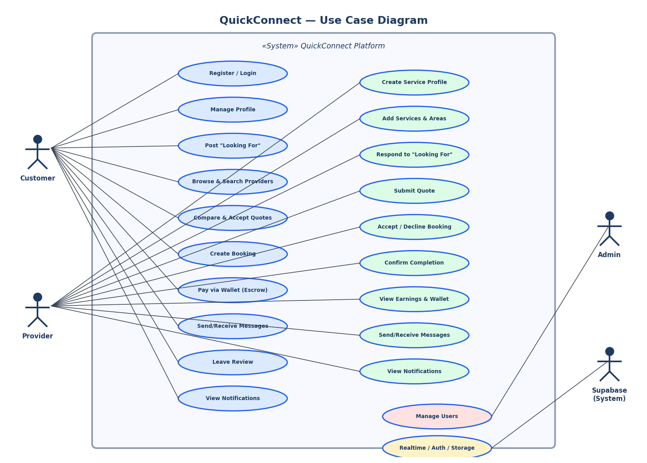
Figure 3.1: QuickConnect Use Case Diagram

The Customer actor has the broadest set of interactions: registering and logging in, posting service requests through the "Looking For" feature, browsing and contacting providers, managing bookings, making wallet payments, exchanging messages, and leaving reviews. The Provider actor focuses on profile and service management, responding to customer requests through quotes and Looking For responses, confirming booking completion, and managing earnings. The Admin actor oversees platform health by managing users, reviewing moderation reports, and resolving payment disputes. The Supabase system actor handles authentication token management, real-time event delivery, and background email notifications.

3.3.2 Data Flow Diagram (Level 0 — Context Diagram)
Figure 3.2 presents the Level 0 (context) data flow diagram, showing QuickConnect as a single process at the centre and the external entities and data stores that interact with it. This high-level view establishes the system boundary and identifies all external data sources and destinations.
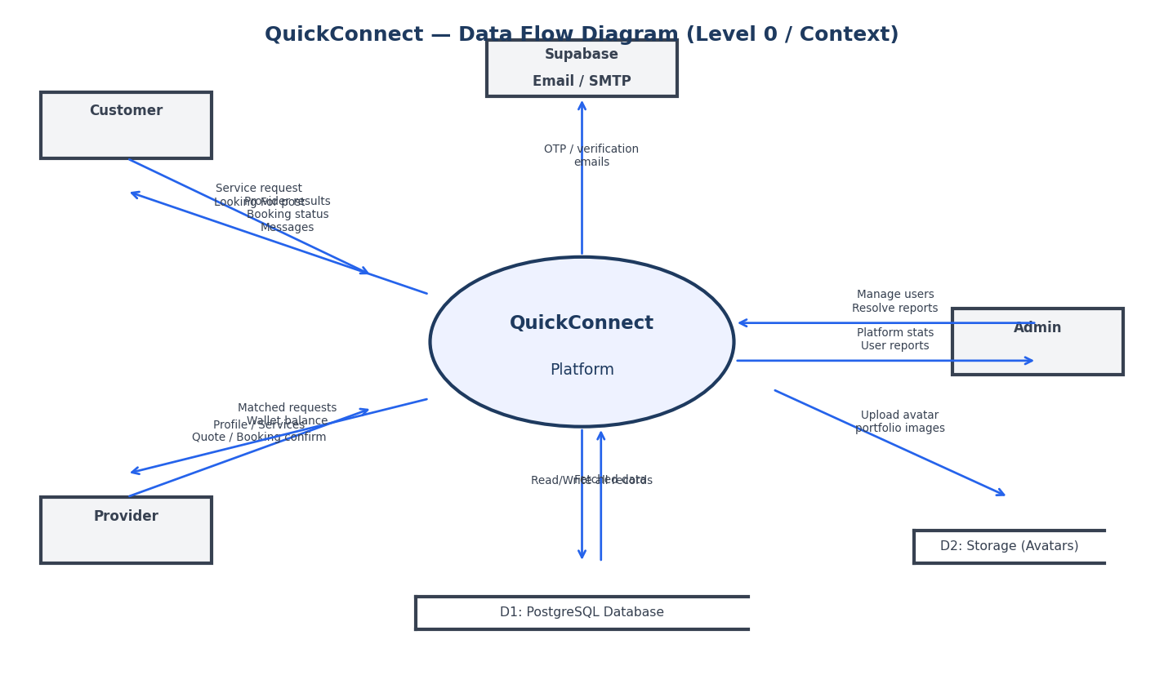
Figure 3.2: QuickConnect Data Flow Diagram (Context Level)

Customers supply service requests, Looking For posts, and booking confirmations to the platform, receiving in return search results, booking status updates, and real-time messages. Providers supply profile data, service listings, and quotes, receiving matched customer requests and wallet credits upon service completion. The Admin actor supplies management commands (user actions, report resolutions, payment decisions) and receives aggregated platform statistics. The PostgreSQL database is the primary data store for all transactional records, while the Supabase Storage service holds avatar and portfolio image files. An external email service (routed through Supabase SMTP) handles OTP delivery and account verification emails.

3.3.3 State Transition Diagram — Booking Lifecycle
Figure 3.3 presents the state transition diagram for the booking entity, which is the central coordinating object in QuickConnect's service delivery workflow. The diagram captures all valid states and the events or conditions that trigger transitions between them.
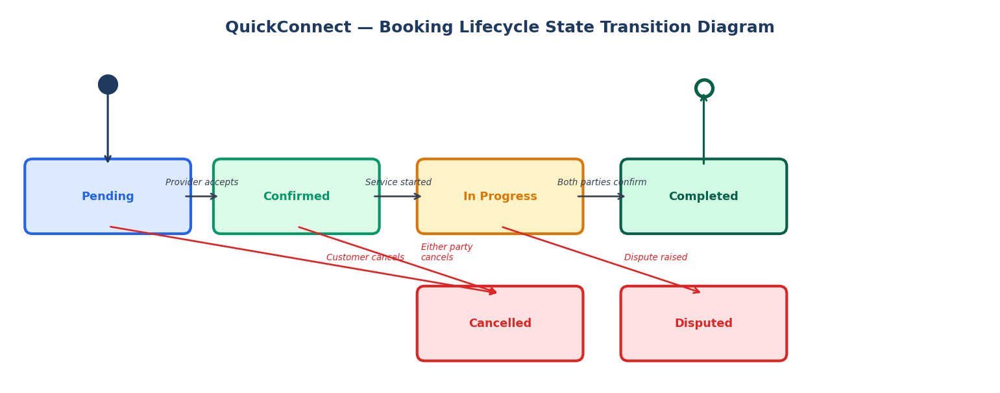
Figure 3.3: Booking Lifecycle State Transition Diagram

A booking begins in the Pending state when created (either directly by a customer or as a result of accepting a Looking For response). The provider transitions it to Confirmed upon accepting the request. Once the provider begins the service, the booking moves to In Progress. Successful completion of the service triggers the Completed state when both the customer and provider confirm — this dual confirmation is what triggers the wallet escrow release to the provider. At any point before completion, either party may cancel (transitioning to Cancelled), and a dispute raised during the In Progress phase transitions the booking to Dispute for admin resolution. The state diagram directly informs the design of the payments escrow mechanism described in Chapter 4.

CHAPTER 4: SYSTEM DESIGN SPECIFICATION
This chapter translates the requirements defined in Chapter 3 into a concrete design blueprint for QuickConnect. Each design decision is traceable to a corresponding requirement and informed by the literature examined in Chapter 2. The chapter covers the overall system architecture, database design, interface design, functional design, and security design.

4.1 System Architecture
QuickConnect adopts a four-tier Jamstack architecture in which a React single-page application (SPA) served via GitHub Pages communicates exclusively with Supabase as its backend platform. This design was chosen because it eliminates the need to provision, maintain, and secure a custom application server, which would be impractical within the scope and timeline of a final-year capstone project. The architecture separates concerns into four distinct layers: the client layer, the application layer, the backend-as-a-service layer, and the data/external services layer.

4.1.1 Client Layer
All user interaction occurs through a browser-based progressive web application built with React 19 and TypeScript. The PWA is bundled by Vite 7 with a Workbox service worker that caches static assets locally, enabling the application to function under intermittent connectivity — an important consideration for users in areas with variable 3G/4G coverage across Botswana. Three client contexts are supported: standard web browsers (desktop and mobile), mobile browsers accessing the installed PWA, and admin users accessing the restricted administrative interface.

4.1.2 Application Layer
The application layer consists of React components, context providers, and custom hooks that implement all business logic on the client side. Business logic includes authentication state management via AuthContext, real-time notification delivery via NotificationContext, routing protected by role checks, and wallet/escrow payment flows driven by Supabase RPC calls. Sensitive write operations — such as wallet debits, payment releases, and administrative refunds — are intentionally handled inside PostgreSQL SECURITY DEFINER functions on the server, ensuring the client cannot manipulate financial data by crafting malicious API requests.

4.1.3 Backend-as-a-Service Layer
Supabase provides five integrated services that collectively form the backend: PostgreSQL for relational data storage with PostGIS spatial extensions; GoTrue for JWT-based authentication with email/password and OTP support; PostgREST for auto-generated REST endpoints derived directly from the database schema; Supabase Realtime for WebSocket subscriptions used in messaging and notifications; and Supabase Storage for avatar and portfolio image hosting with CDN delivery. Two Deno-based Edge Functions — send-otp and verify-otp — extend the platform with server-side OTP generation and validation for the optional two-factor authentication feature.

4.1.4 Architecture Diagram
Figure 4.1 illustrates the full system architecture and the data flows between layers.
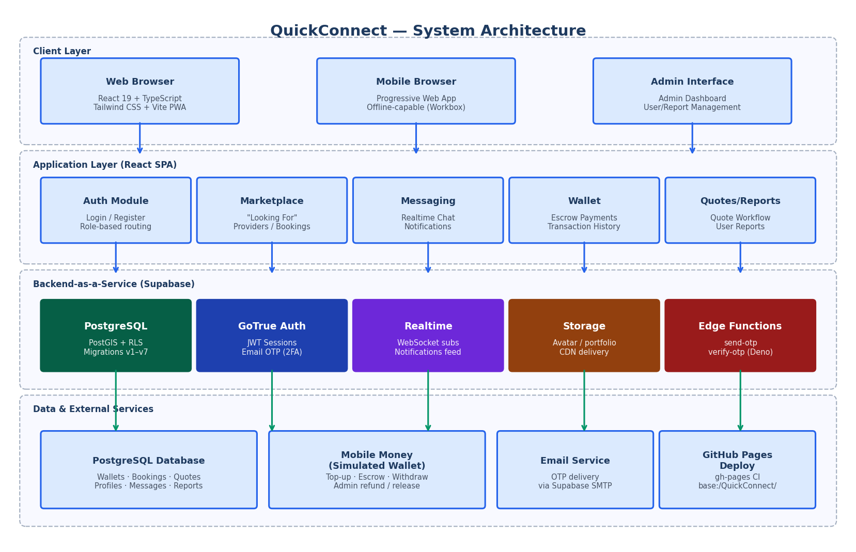
Figure 4.1: QuickConnect System Architecture

4.2 Database Design Specification
The database is a normalised PostgreSQL schema hosted on Supabase Cloud. It has evolved through seven sequential migration scripts (schema.sql through migration_v7.sql), with each migration introducing new tables, constraints, triggers, and RLS policies without breaking existing data. The design follows third normal form (3NF) to minimise redundancy while using denormalised aggregate columns (e.g., rating_avg and review_count on service_providers) where read performance demands it.

4.2.1 Core Tables
Table | Primary Key | Foreign Keys | Key Attributes | Purpose
profiles | id (= auth.users.id) | — | full_name, role, phone, avatar_url, two_fa_enabled | One-to-one extension of Supabase Auth user record. Role determines access throughout the platform.
service_providers | id (UUID) | profile_id → profiles | business_name, bio, rating_avg, review_count, is_verified | Holds provider-specific data linked to the owning profile. Created automatically by trigger on registration.
service_categories | id (UUID) | — | name, icon, description | Predefined set of service categories (plumbing, cleaning, etc.) managed by admins.
services | id (UUID) | provider_id → service_providers, category_id → service_categories | title, description, price_min, price_max, duration_hours | Individual service offerings listed by a provider under a category.
service_areas | id (UUID) | provider_id → service_providers | city, district, coordinates (GEOGRAPHY) | Geospatial coverage areas for providers, leveraging the PostGIS extension.
looking_for_posts | id (UUID) | customer_id → profiles, category_id → service_categories | title, description, budget_min, budget_max, urgency, status, expires_at | Customer-posted service requests that providers can respond to with quotes.
looking_for_responses | id (UUID) | post_id → looking_for_posts, provider_id → service_providers | message, proposed_price, status | Provider responses to a Looking For post. Customer can accept one to create a booking.
bookings | id (UUID) | customer_id → profiles, provider_id → service_providers | status, scheduled_at, location, customer_confirmed, provider_confirmed | Central booking record tracking the full service lifecycle with dual-confirmation for payment release.
payments | id (UUID) | booking_id → bookings | amount, method (wallet/orange_money/…), status (held/released/refunded/disputed) | Payment record linked to a booking. Wallet payments use the escrow-hold mechanism.
wallets | id (UUID) | user_id → profiles | balance (DECIMAL, ≥0) | One wallet per user, auto-created by trigger on profile insert.
wallet_transactions | id (UUID) | wallet_id → wallets | type (top_up/payment_hold/…), direction, amount, reference_id | Immutable ledger of all wallet movements for full auditability.
conversations | id (UUID) | booking_id → bookings, customer_id/provider_id → profiles | created_at | Container for a messaging thread linked to a booking.
messages | id (UUID) | conversation_id → conversations, sender_id → profiles | content, created_at | Individual messages within a conversation.
quotes | id (UUID) | customer_id → profiles, provider_id → service_providers, booking_id → bookings | service_description, budget_min/max, quoted_amount, status (requested/quoted/accepted/rejected/expired) | Direct quote request flow from customer to a specific provider, independent of Looking For posts.
reports | id (UUID) | reporter_id/reported_user_id → profiles | reason (enum), description, status, admin_notes | User moderation reports reviewed by admins. Unique constraint prevents duplicate open reports.
notifications | id (UUID) | user_id → profiles | type, title, body, is_read, reference_id | In-app notifications delivered in real time via Supabase Realtime subscription.
reviews | id (UUID) | booking_id → bookings, reviewer_id/provider_id → profiles | rating (1–5), comment | Post-completion reviews that update provider rating_avg via trigger.

4.2.2 Entity Relationship Diagram
Figure 4.2 presents the complete entity relationship diagram for the QuickConnect database, showing all tables, their attributes, and the relationships between them.
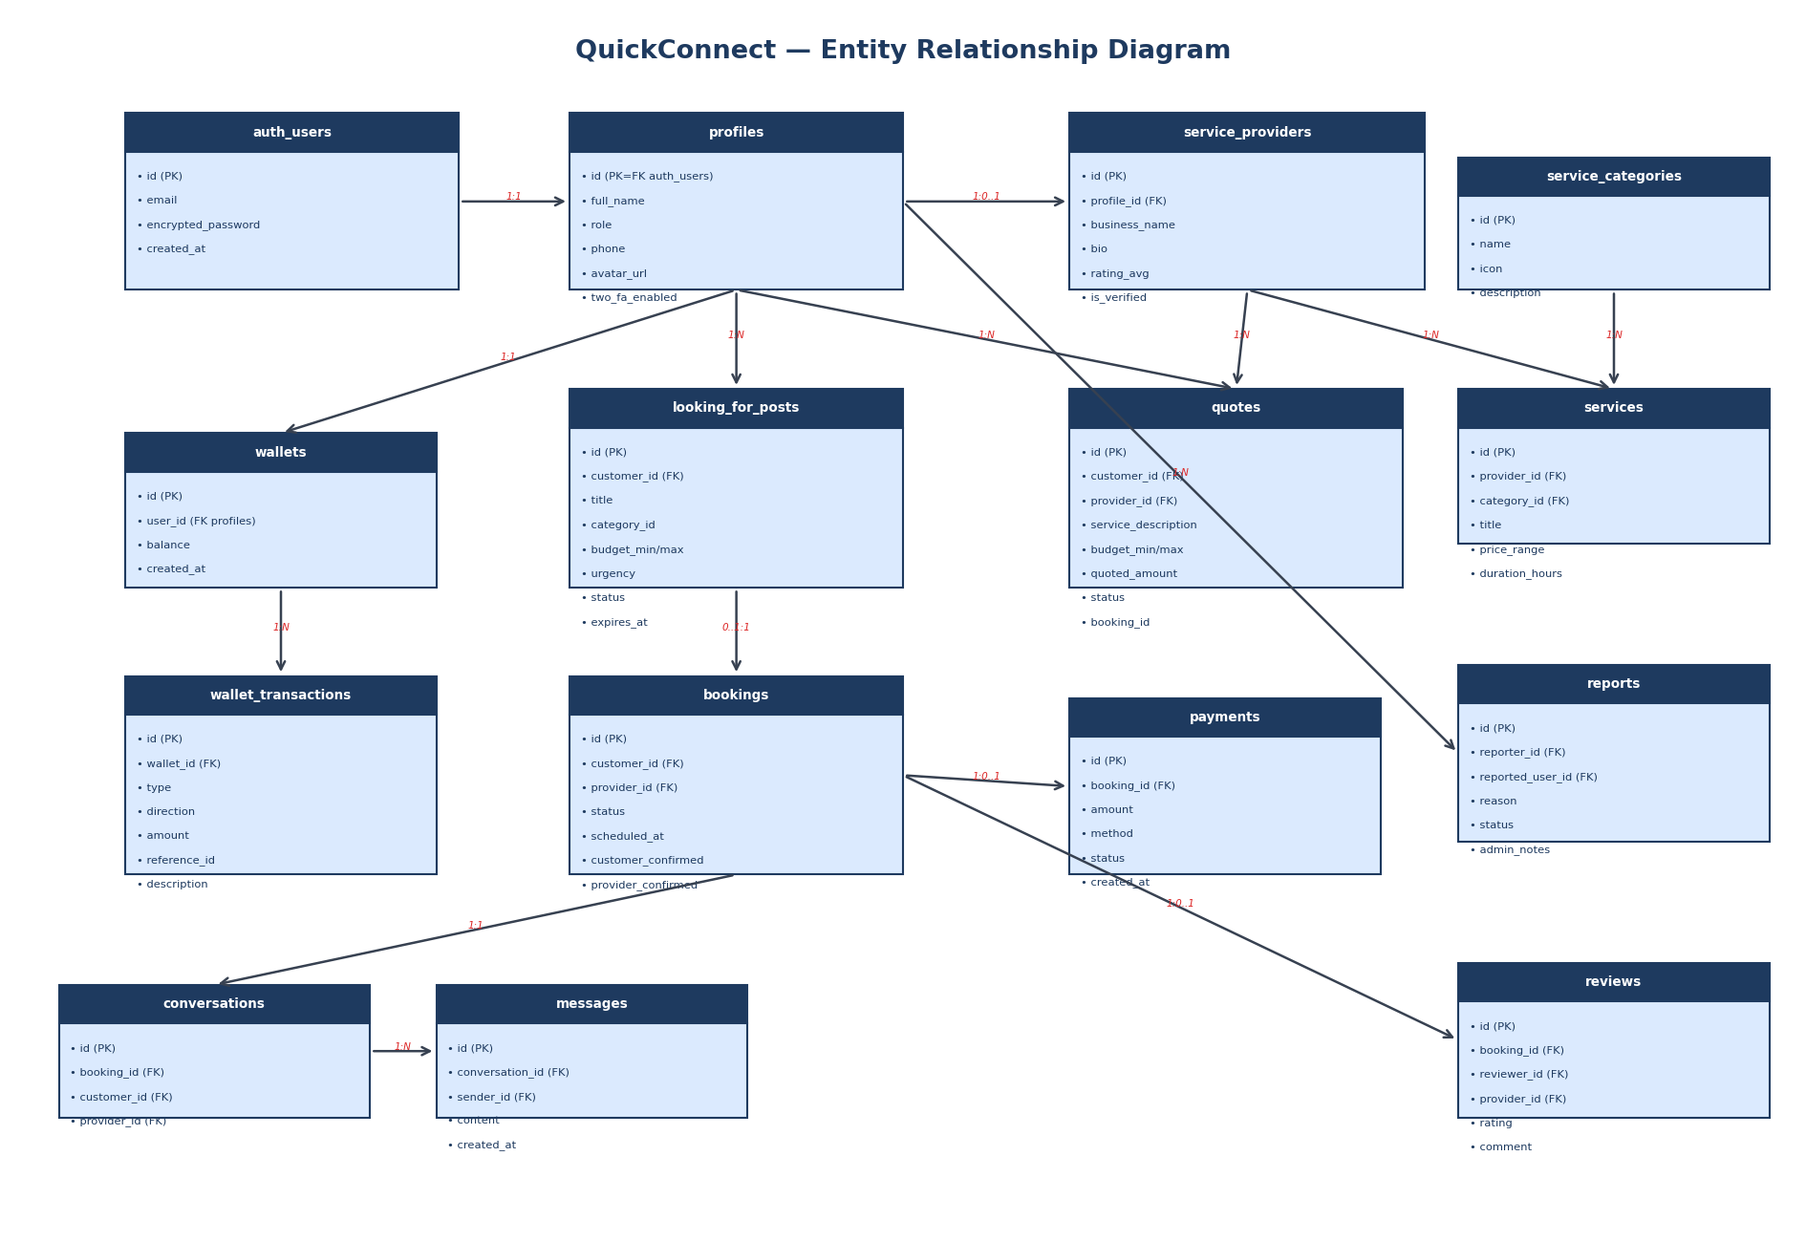
Figure 4.2: QuickConnect Entity Relationship Diagram

4.2.3 Database Triggers and SECURITY DEFINER Functions
Several PostgreSQL triggers enforce business rules automatically, removing the possibility of a client bypassing them through direct API calls:

Trigger / Function | Event | Purpose
handle_new_user() | AFTER INSERT on auth.users | Creates a profile record and, when role=provider, a service_providers row.
create_wallet_for_new_profile() | AFTER INSERT on profiles | Automatically provisions a zero-balance wallet for every new user.
set_updated_at() | BEFORE UPDATE on any audited table | Keeps the updated_at column current without requiring client intervention.
auto_release_payment_on_both_confirmed() | BEFORE UPDATE on payments | Credits the provider wallet and sets payment.status=released when both customer_confirmed and provider_confirmed are true on a held payment.
update_provider_rating() | AFTER INSERT/UPDATE on reviews | Recalculates rating_avg and increments review_count on the related service_providers row.
top_up_wallet(p_amount) | RPC called by client | Atomically credits the calling user's wallet and records the transaction.
initiate_wallet_payment(p_booking_id, p_amount) | RPC called by client | Checks balance, debits customer wallet, creates an escrow-held payment record.
admin_refund_payment(p_payment_id) | RPC called by admin | Refunds a held/disputed payment back to the customer wallet.
admin_release_payment(p_payment_id) | RPC called by admin | Releases a held/disputed payment to the provider wallet.
withdraw_from_wallet(p_amount) | RPC called by client | Validates withdrawal range (P20–P5000) and debits the user's wallet (simulated payout).

4.2.4 Row Level Security Strategy
Every table in the QuickConnect schema has RLS enabled. The policy design follows three guiding principles: users can only read their own records (e.g., a customer cannot read another customer's wallet); providers see only their own service data and the quotes/bookings directed at them; admin users bypass standard restrictions using an EXISTS sub-query against the profiles table. Sensitive financial write operations are excluded from client-accessible policies entirely and implemented only through SECURITY DEFINER RPC functions, which execute with elevated database privileges regardless of the calling user's JWT.

4.3 Interface Design Specification

4.3.1 Design Principles
The QuickConnect interface was designed around four principles drawn from Nielsen's (1994) usability heuristics and the mobile-first requirements established in Chapter 3:
• Visibility of system status — every asynchronous operation displays a loading spinner, and every completed action displays a success or error toast notification.
• Match between system and the real world — service categories use familiar Botswana trade terminology; currency is displayed in Botswana Pula (BWP, P).
• Consistency and standards — a shared UI component library (Button, Card, Modal, Input, Select, Badge, StarRating, EmptyState) ensures visual and interaction consistency across all pages.
• Error prevention — all forms validate inputs in real time before submission; destructive actions (booking cancellation, withdrawal) require a confirmation modal.

4.3.2 Layout System
A context-aware Layout component selects the appropriate page shell based on authentication state and route. Unauthenticated routes (Login, Register) render a centred card with the QuickConnect logo. The home page renders full-bleed with a hero section. All authenticated routes render a three-column layout: a fixed sidebar on the left for primary navigation, a main content area in the centre, and a top header bar providing search, notifications, and the user menu.

4.3.3 Colour Palette and Typography
Element | Value | Usage
Brand Blue | #261CC1 | Primary action buttons, active navigation, brand identity
Navy | #1E3A5F | Headings, sidebar background, emphasis text
Light Blue | #DBEAFE | Card backgrounds, table alternating rows, chips
Success Green | #059669 | Confirmed status badges, success messages
Warning Orange | #D97706 | Pending status, urgency indicators
Error Red | #DC2626 | Error messages, cancelled status, report alerts
Body Text | Times New Roman 12pt / Tailwind default 14–16px | Primary content text
Headings | Semibold 18–24px | Page and section titles
Code / Monospace | Courier 10pt | Code snippets in documentation

4.3.4 Key Screen Designs
The following screens represent the core user journeys in QuickConnect. Each was implemented iteratively, with the design refined based on supervisor feedback during weekly milestone demonstrations.
Screen | Route | Primary Purpose | Key UI Elements
Home | / | Entry point and service discovery | Hero section with search bar; category grid with 15 icons/colours; featured providers
Register | /register | Account creation with role selection | Email/password fields; customer vs provider toggle; business name field (providers only)
Login | /login | Authentication | Email/password form; redirect to dashboard on success
Provider Search | /providers | Browse/filter providers | Category filter chips; provider cards (rating, services, area); pagination
Provider Profile | /providers/:id | View provider details | Avatar; service list; ratings/reviews; "Request Quote" and "Book" CTA buttons
Create Post | /create-post | Post a Looking For request | Title, description, category selector, budget range sliders, urgency dropdown, deadline picker
Post Detail | /posts/:id | View responses to a Looking For post | Post summary; provider response list with accept/reject actions; status badge
My Bookings | /bookings | Manage bookings as customer | Status tabs (pending/confirmed/completed); booking cards with Pay and Confirm buttons
Dashboard | /dashboard | Provider operations hub | Incoming booking requests; category-matched Looking For posts; earnings summary
Chat | /chat/:id | Real-time messaging | Message thread; auto-scroll to latest; input box with send button
Wallet | /wallet | Financial management | Balance card; transaction history table; top-up and withdraw modals
Quotes | /quotes | Quote request management | Quote list with status badges; provider response form; accept/reject actions
Admin Dashboard | /admin | Platform oversight | Statistics cards (users, bookings, revenue); quick links to sub-sections
Admin Reports | /admin/reports | Dispute and report management | Report list with reason filters; refund/release payment buttons; admin notes field

4.3.5 Interface Wireframes
The following wireframes illustrate the visual layout and interactive structure of the nine primary screens in QuickConnect. Each wireframe follows standard greyscale wireframe conventions: solid rectangles represent UI panels and cards; crossed rectangles represent image placeholders; dark rectangles represent primary action buttons; and outlined rectangles represent secondary or cancel actions. The wireframes were produced iteratively, with each version reviewed against the functional requirements in Chapter 3 to confirm that all required interactions are exposed at the appropriate level of the interface hierarchy.

Figure 4.5 — WF-1: Home / Landing Page
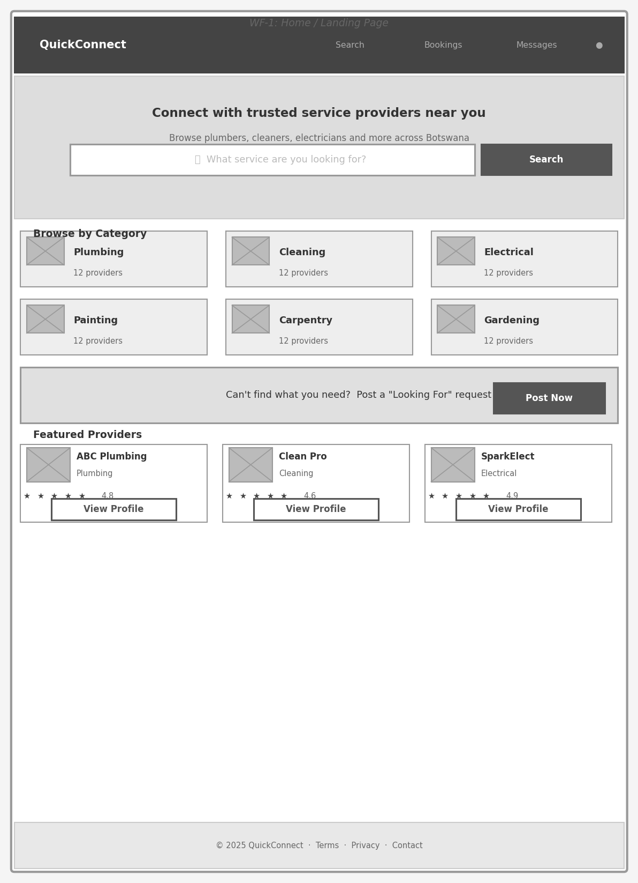
Figure 4.5: WF-1: Home / Landing Page
The Home page presents a hero section with a full-width search bar, a six-category browsing grid, a "Looking For" call-to-action banner, and a row of featured provider cards. This layout ensures that both primary user journeys — browsing by category and posting a service request — are accessible within one scroll of the landing page.

Figure 4.6 — WF-2: Register / Sign Up
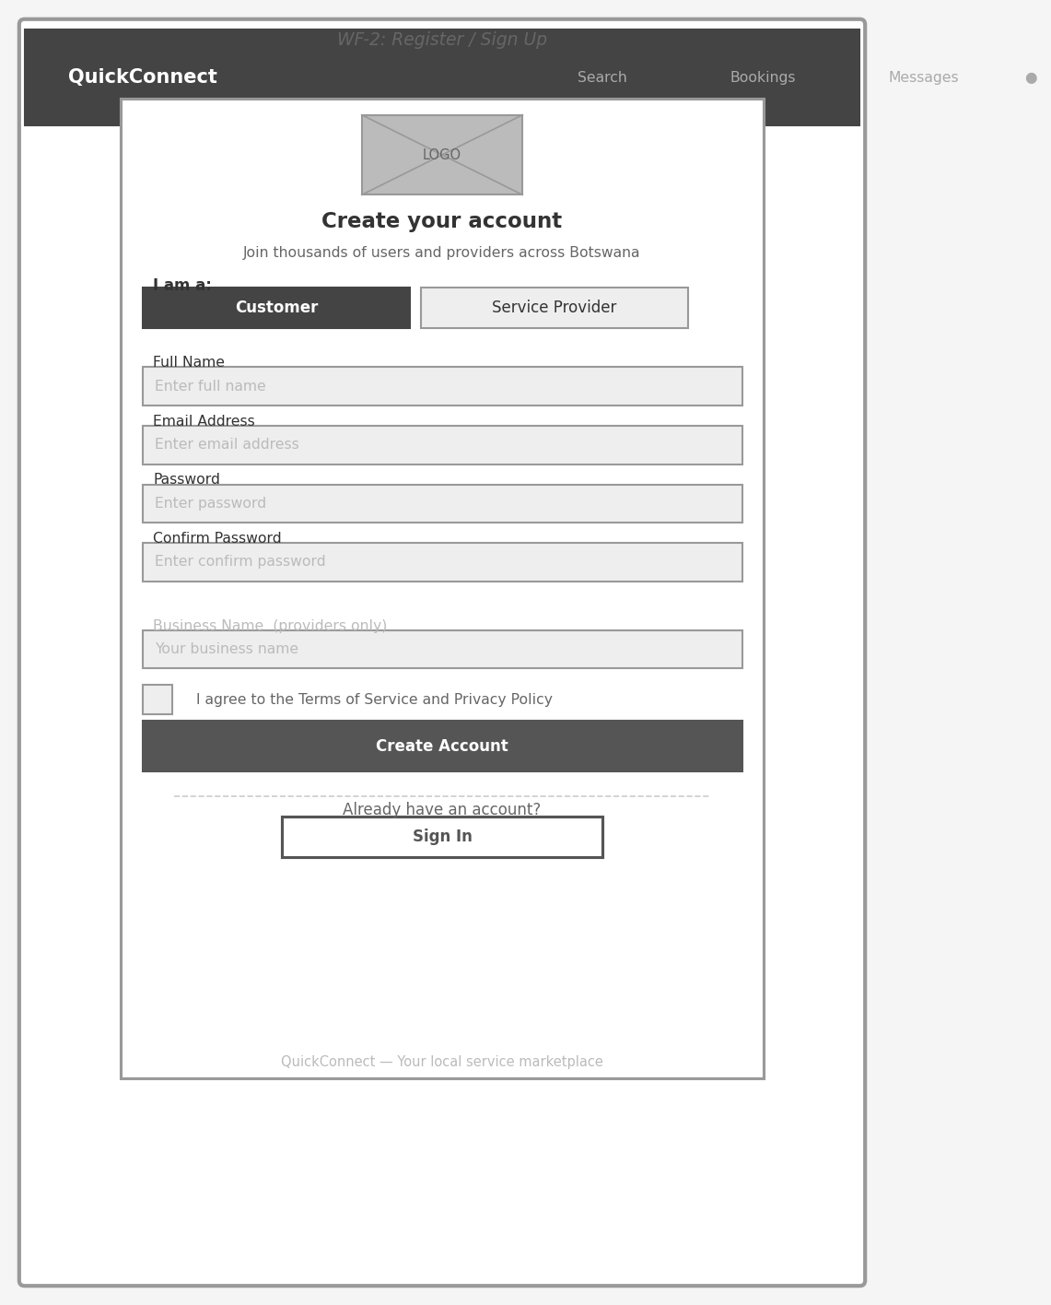
Figure 4.6: WF-2: Register / Sign Up
The registration screen uses a role-selection toggle at the top to switch between Customer and Service Provider flows. Provider registration reveals an additional business name field. The layout follows a single-column card design suitable for both desktop and mobile viewports.

Figure 4.7 — WF-3: Create "Looking For" Post
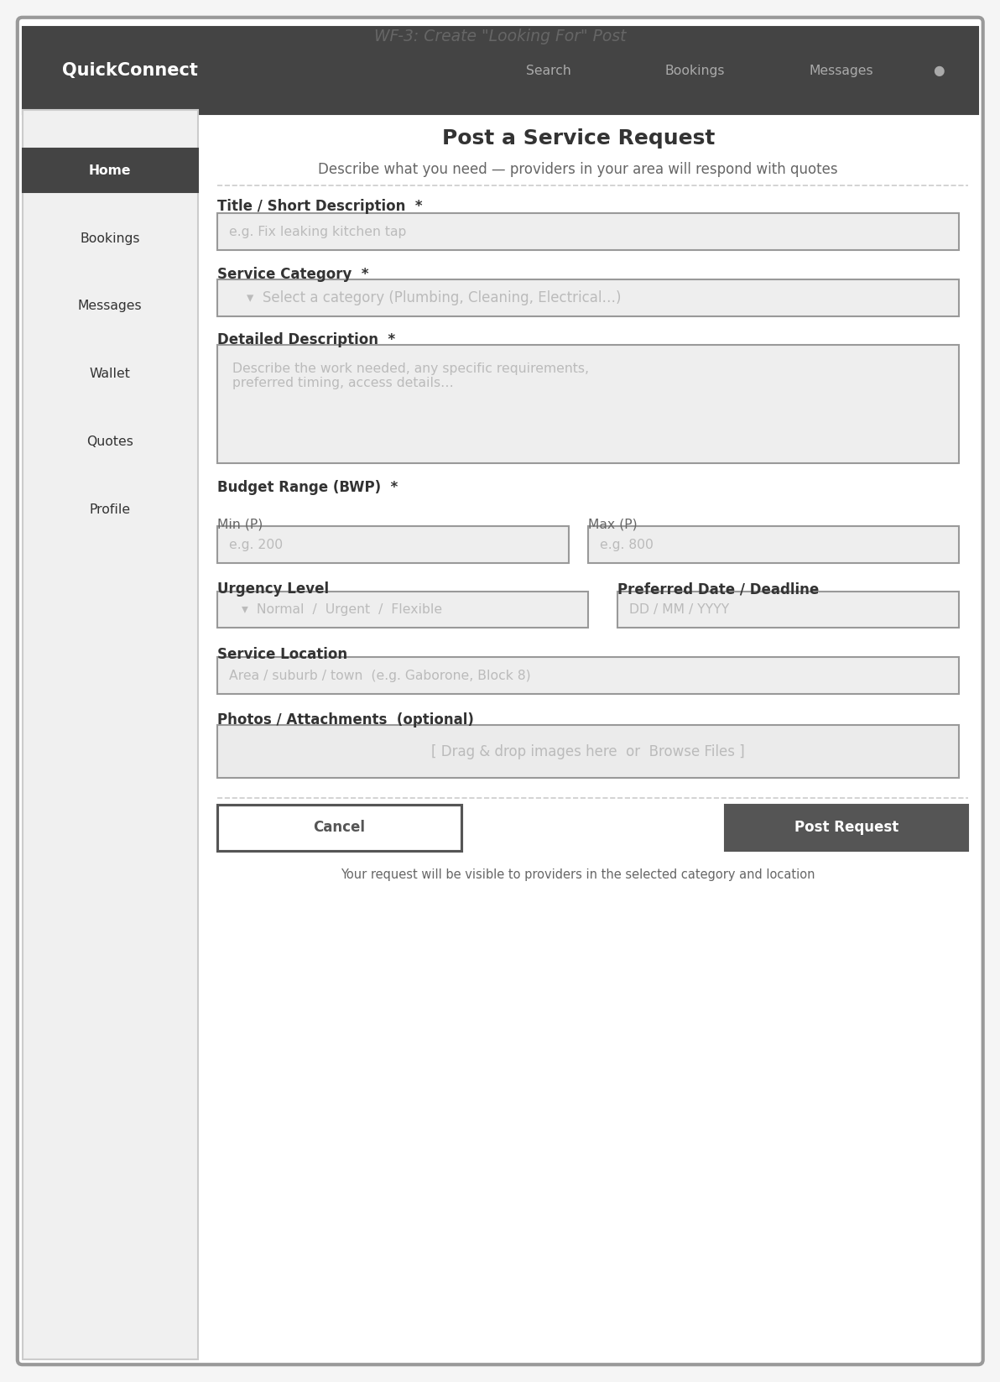
Figure 4.7: WF-3: Create "Looking For" Post
The post-creation form captures all information a provider needs to submit a relevant quote: title, category, detailed description, budget range, urgency level, preferred date, service location, and optional photo attachments. Required fields are marked with an asterisk. The sidebar remains visible for authenticated users to retain navigation context.

Figure 4.8 — WF-4: Provider Search Results
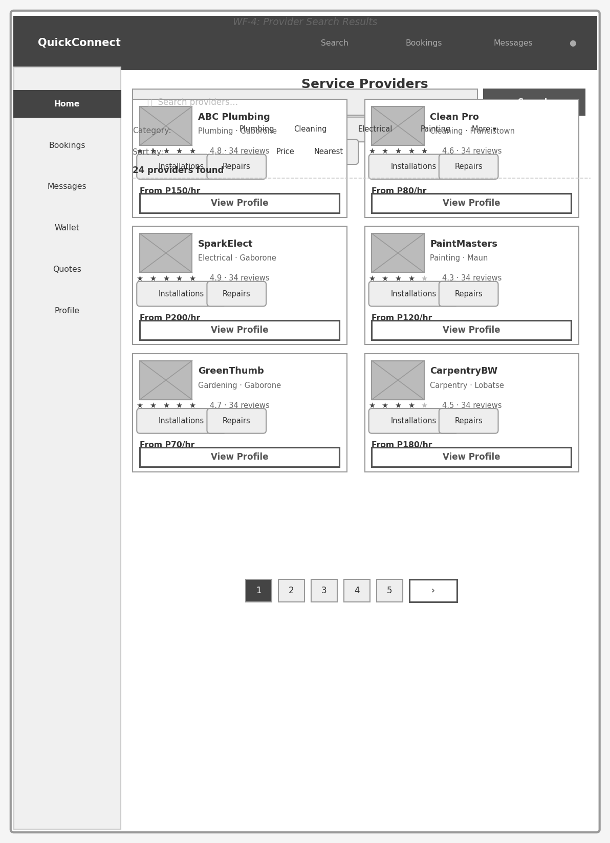
Figure 4.8: WF-4: Provider Search Results
The provider search page provides category filter chips, sort options (Top Rated, Price, Nearest), and a paginated grid of provider cards. Each card surfaces the most decision-critical information: business name, category, location, star rating, review count, service tags, and starting price — enabling customers to compare options without navigating away.

Figure 4.9 — WF-5: Provider Profile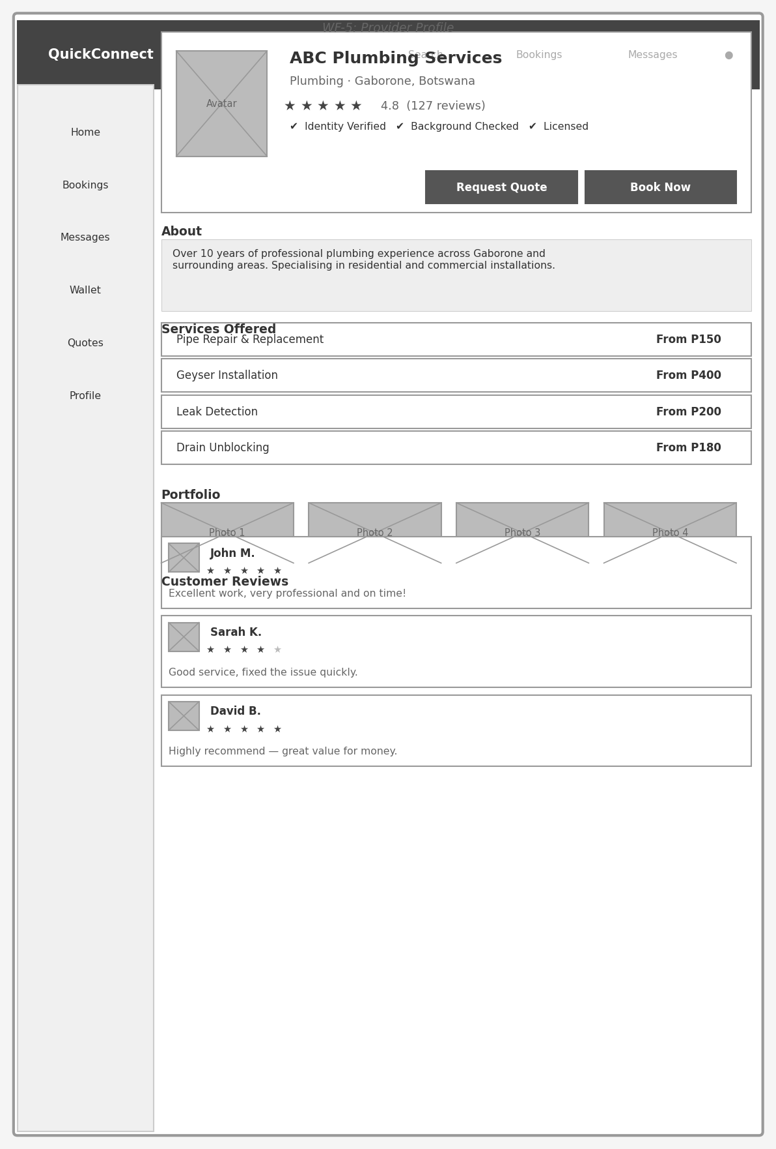

Figure 4.9: WF-5: Provider Profile
The provider profile page is the primary trust-building surface. It presents verification badges, star rating, service listings with pricing, a portfolio image gallery, and paginated customer reviews. Two primary calls-to-action — "Request Quote" and "Book Now" — are placed in the profile header for immediate access.

Figure 4.10 — WF-6: My Bookings (Customer View)
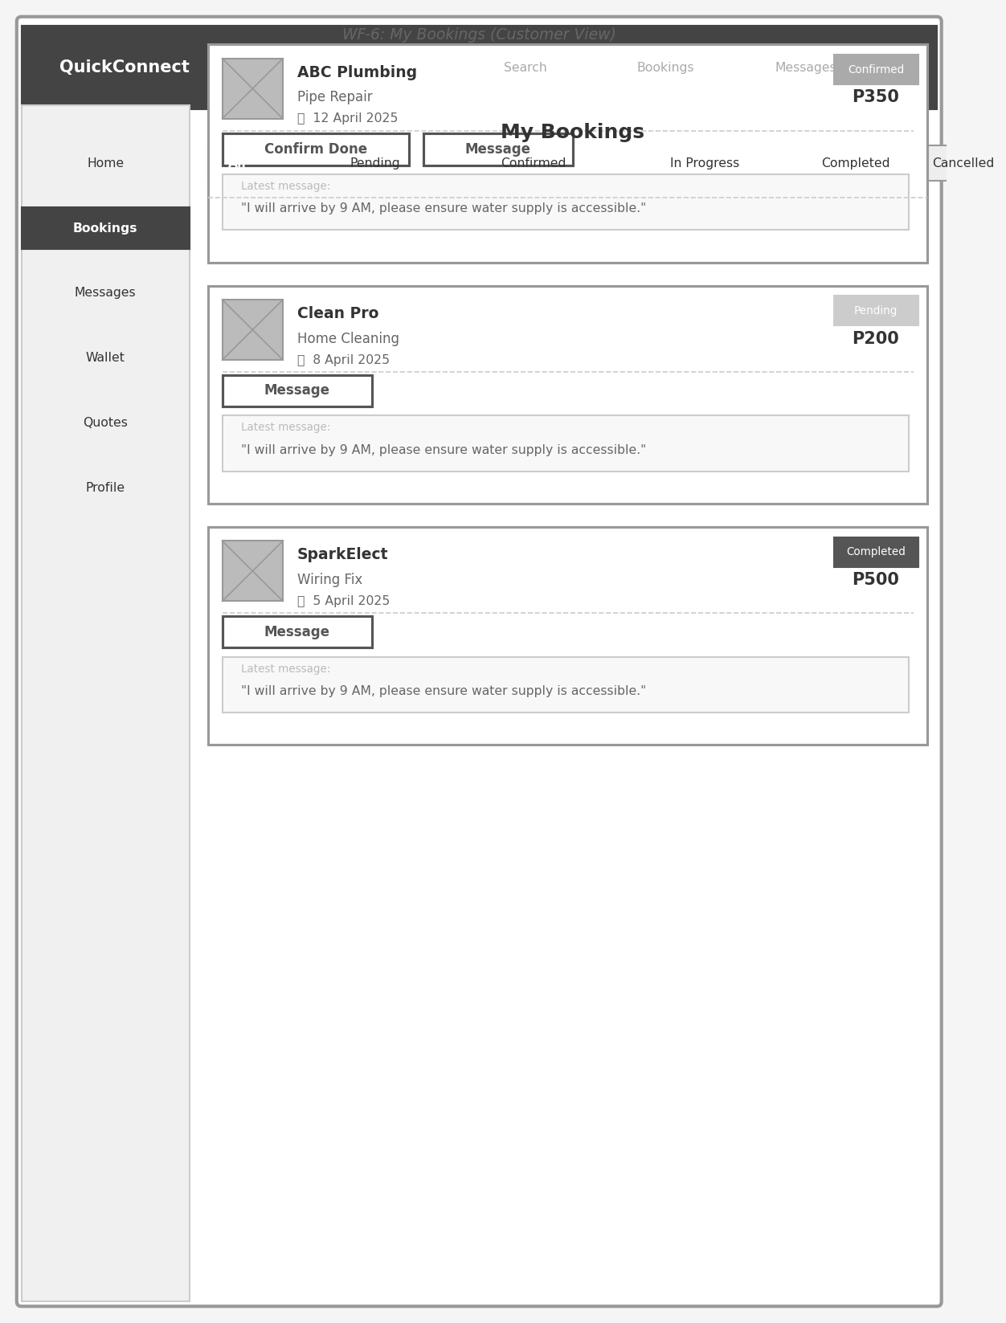
Figure 4.10: WF-6: My Bookings (Customer View)
The bookings screen uses a status tab bar to filter by booking lifecycle stage. Each booking card shows the provider, service, date, status badge, and amount, followed by context-sensitive action buttons: "Pay via Wallet" appears only on confirmed but unpaid bookings, "Confirm Done" on active bookings, and "Leave Review" on completed unreviewed bookings. A message preview is shown at the bottom of each card for quick context.

Figure 4.11 — WF-7: Wallet
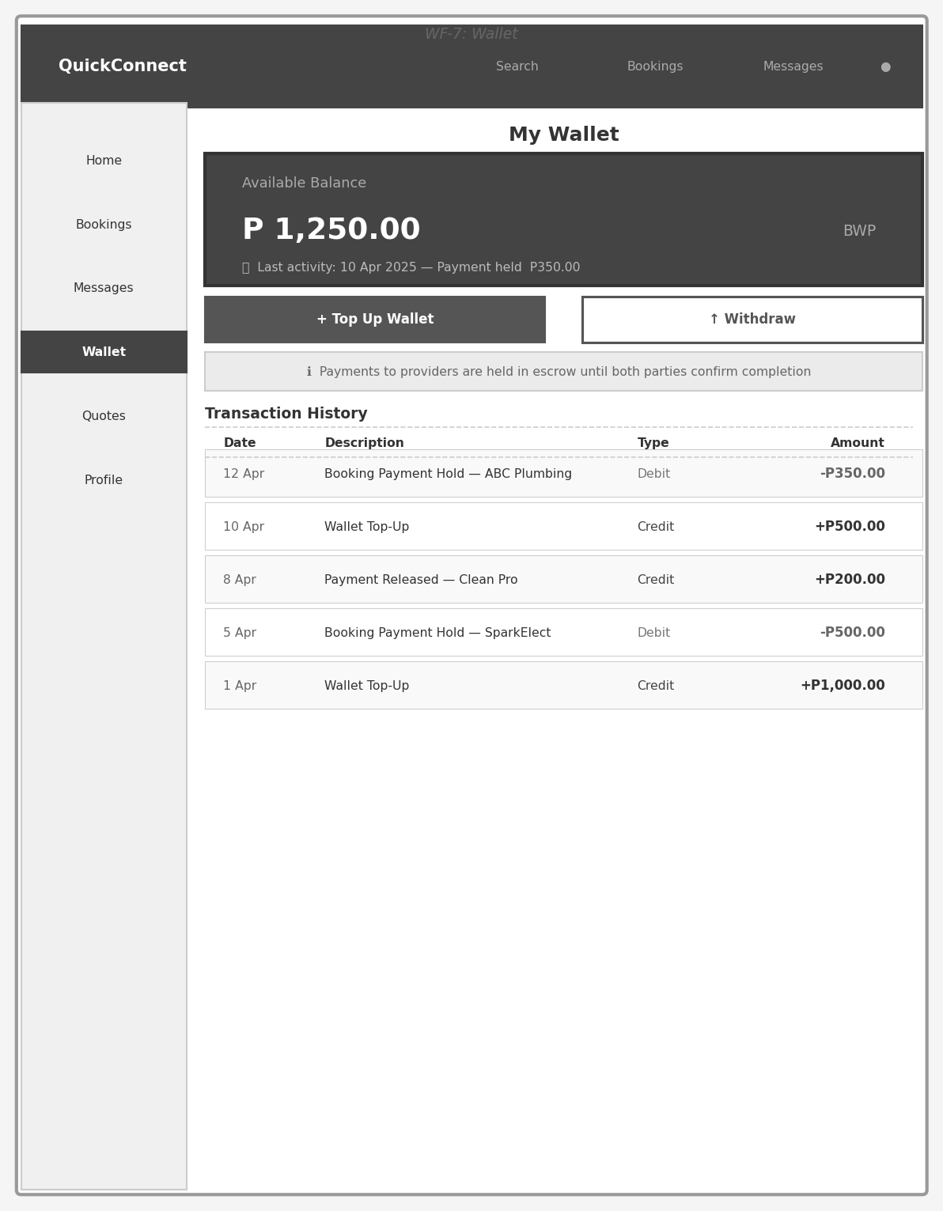
Figure 4.11: WF-7: Wallet
The wallet screen prominently displays the current balance on a dark card, followed by Top Up and Withdraw action buttons. An information banner explains the escrow mechanism to users unfamiliar with held payments. The transaction history table below lists all wallet movements with date, description, type, and amount, with alternating row shading for readability.

Figure 4.12 — WF-8: Real-time Messaging (Chat)
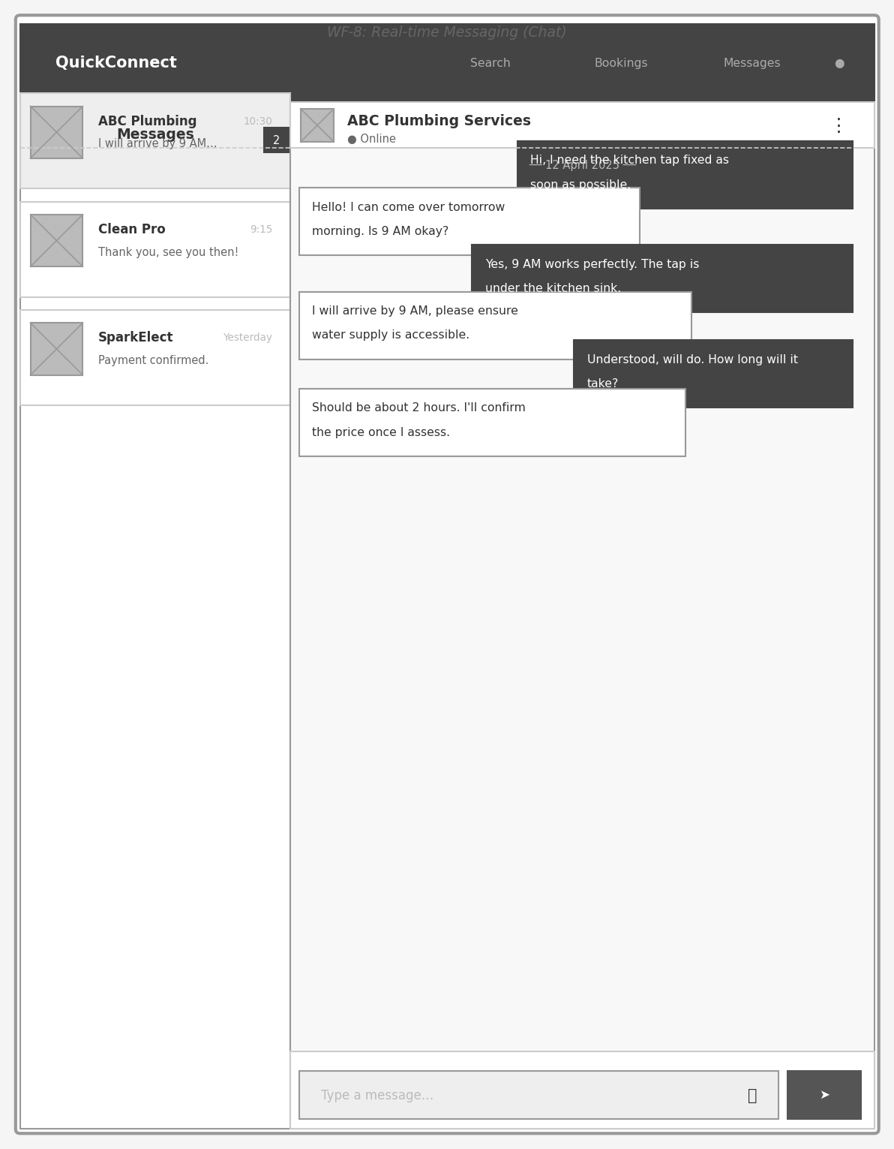
Figure 4.12: WF-8: Real-time Messaging (Chat)
The chat interface uses a two-panel layout: a conversation list on the left and the active message thread on the right. Sent messages appear right-aligned with a dark background; received messages appear left-aligned on white. An unread message count badge is shown on conversations with new messages. The input area includes a file attachment button alongside the text entry field and send button.

Figure 4.13 — WF-9: Provider Dashboard
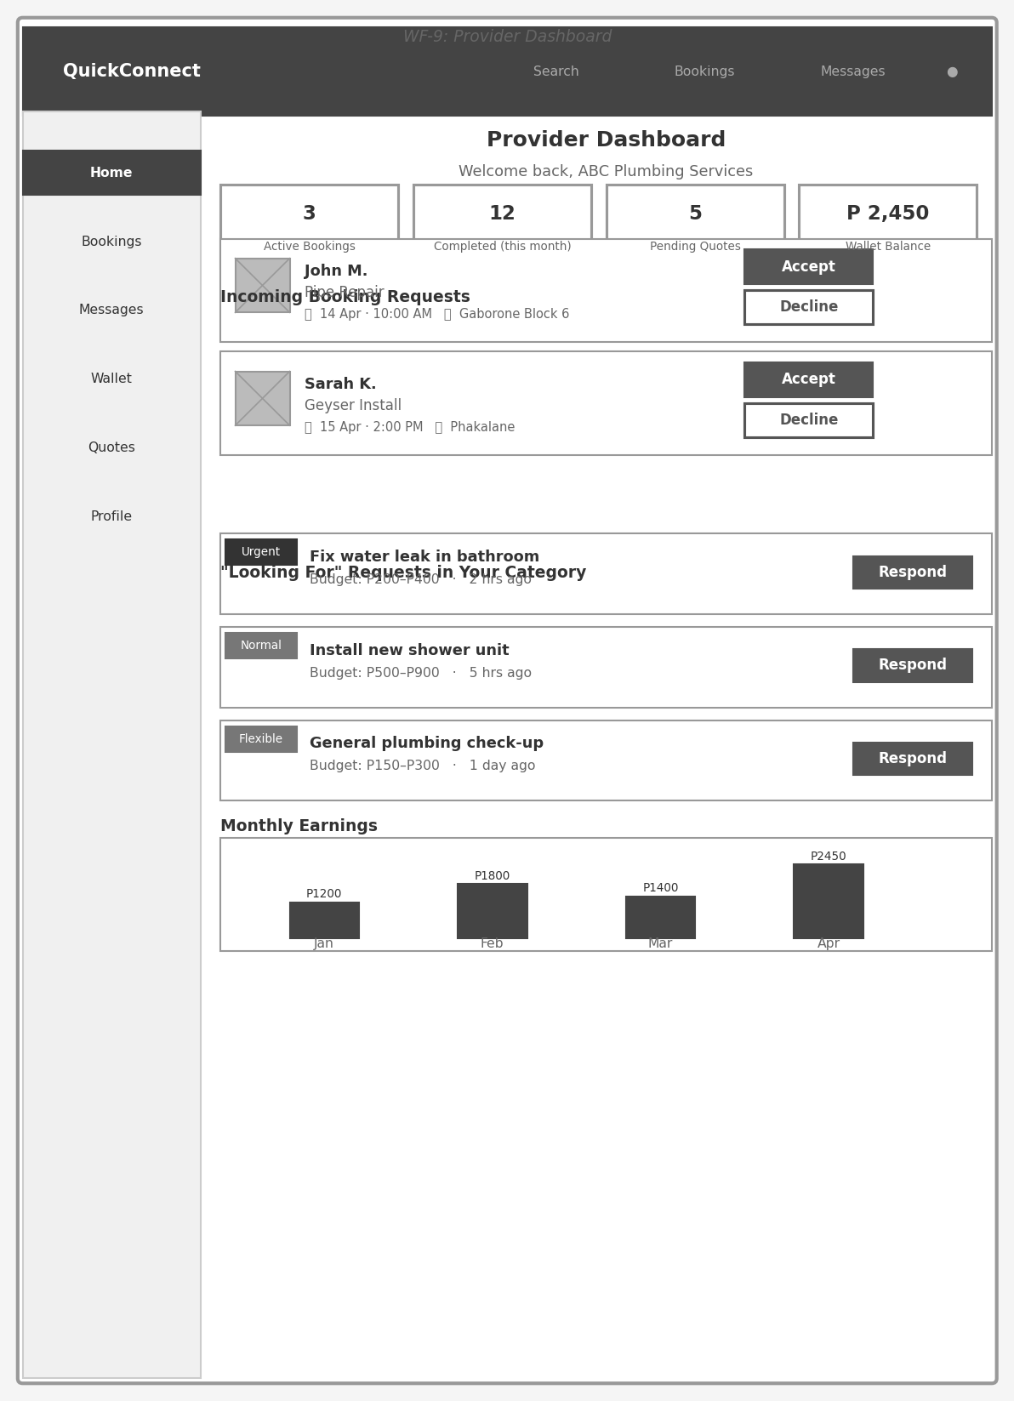
Figure 4.13: WF-9: Provider Dashboard
The provider dashboard consolidates four key metrics (active bookings, monthly completions, pending quotes, wallet balance) in a stats row. Below this, incoming booking requests are listed with Accept/Decline actions. A "Looking For" section shows customer posts matching the provider's service categories, with urgency badges and respond buttons. A monthly earnings bar chart provides a quick financial overview.

4.4 Functional Design Specification

4.4.1 Component Architecture
The frontend is structured as a hierarchy of React components organised by domain responsibility. Figure 4.3 shows the component diagram illustrating how modules depend on the shared Supabase client library and on each other.
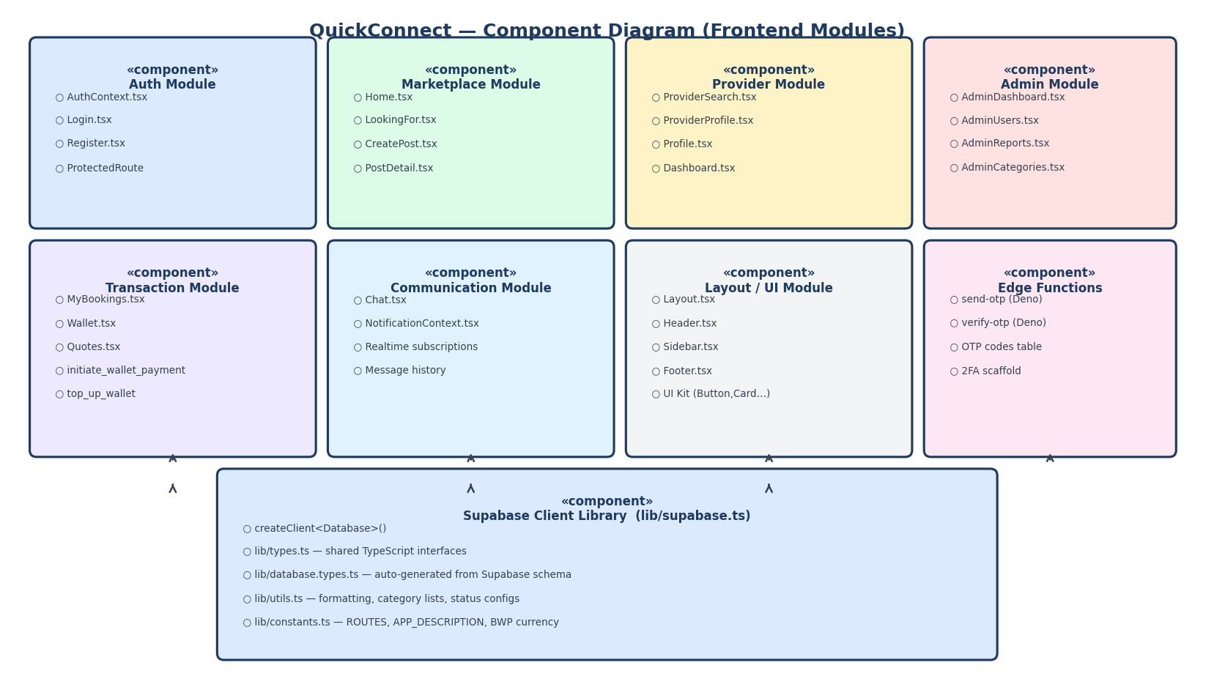
Figure 4.3: QuickConnect Frontend Component Diagram

4.4.2 State Management Strategy
QuickConnect uses React's built-in Context API for global state rather than an external library such as Redux. This decision was deliberate: the application's server-first nature means most state lives in Supabase and is fetched on demand, minimising the amount of local state that needs to be shared across components. Two global contexts are defined:
• AuthContext — holds the current Supabase session, user object, and profile record. It is initialised on page load with getSession() and kept synchronised with onAuthStateChange(). A twelve-second timeout wrapper prevents the application from hanging indefinitely if the network is slow.
• NotificationContext — maintains the list of in-app notifications and subscribes to PostgreSQL realtime change events on the notifications table, providing live updates without polling.

4.4.3 Wallet Escrow Payment Flow
The wallet escrow system is one of the most technically involved flows in the platform. Figure 4.4 shows the sequence of interactions between the browser, the React application, the Supabase RPC layer, and the database when a customer pays for a booking using their QuickConnect wallet.
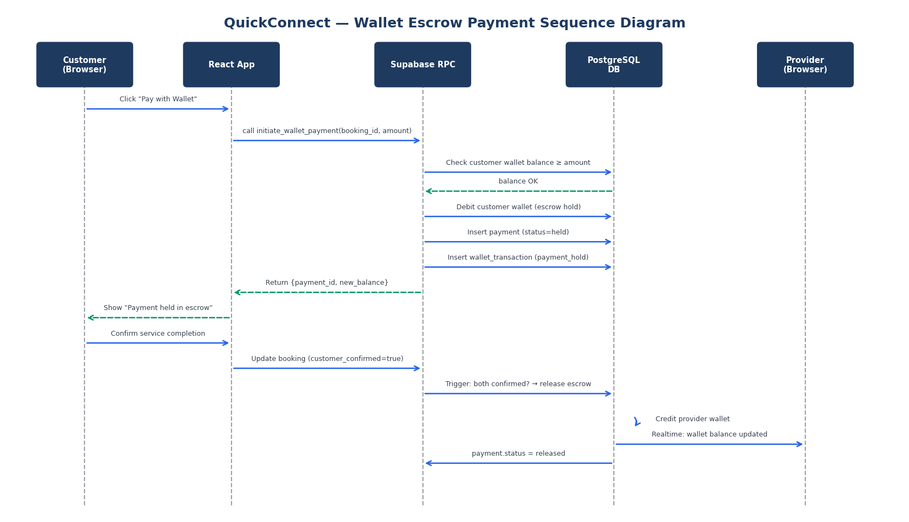
Figure 4.4: Wallet Escrow Payment Sequence Diagram

The key design property of this flow is atomicity: because the balance deduction, the wallet_transaction insert, and the payments record creation all occur inside a single SECURITY DEFINER PostgreSQL function (initiate_wallet_payment), they either all succeed or all roll back. This guarantees that funds cannot be deducted without a corresponding payment record being created, and that a payment record cannot exist without the corresponding balance deduction.

Additional payment behaviour: escrow, disputes, and admin resolution
Beyond the initial pay-in, each payment row progresses through statuses including held (escrow), released, refunded, failed, and disputed. Real wallet escrow is evidenced by a wallet_transactions row of type payment_hold with direction debit and reference_id equal to the booking id; that link is the authoritative signal that customer funds left the wallet for that booking.
When both parties confirm satisfaction while funds are held, the auto_release_payment_on_both_confirmed trigger credits the provider and marks the payment released. If a dispute arises while funds are held, administrators resolve it via SECURITY DEFINER RPCs: admin_refund_payment returns escrow to the customer, and admin_release_payment pays the provider from escrow.
If a customer never paid into escrow but work was completed, a provider may open a dispute that creates a disputed payment record without a prior payment_hold. In that non-escrow scenario, resolving in favour of the provider debits the customer wallet by the claimed amount and credits the provider by the same amount so the ledger remains balanced; resolving in favour of the customer closes the dispute without crediting wallet funds the customer never paid in. The database enforces this distinction by detecting escrow through payment_hold transactions on the booking. Optional admin_dispute_debit_customer supports manual customer debits where platform policy allows negative balances. The Admin Reports interface lists disputed and held payments together with party statements and wallet balances to inform these decisions.

4.4.4 "Looking For" Provider Matching
When a customer creates a Looking For post, the system determines which providers are relevant using a two-stage filter. First, a Supabase query retrieves all service_providers whose services table contains at least one entry matching the selected service_category. Second, if the customer has specified a location, the PostGIS ST_DWithin function filters providers whose service_areas geometry falls within the customer's specified radius. Matched providers receive a notification record (inserted server-side), which their NotificationContext subscription delivers in real time to any active browser session.

4.4.5 Authentication and Session Design
Authentication is handled entirely by Supabase GoTrue. On successful sign-in, GoTrue issues a JWT access token (one-hour expiry) and a longer-lived refresh token stored in the browser's localStorage by the Supabase client library. The refresh token is used transparently to obtain new access tokens without requiring the user to log in again. User metadata (full_name, role, business_name) is embedded in the JWT at registration and triggers the handle_new_user database function to create the corresponding profile and service_providers records.
The optional two-factor authentication (2FA) feature is scaffolded at the database and Edge Function level. The profiles table carries a two_fa_enabled boolean column (added in migration_v6), and the send-otp and verify-otp Edge Functions implement OTP generation using Supabase's admin link generation endpoint, storing the code in the otp_codes table with a five-minute expiry. Integration into the React authentication flow is identified as a near-term enhancement.

4.5 Security Design Specification
Security is implemented at multiple levels in line with the security requirements established in Section 3.2.6. The layered security model means that a compromise at one level does not automatically expose data protected at a lower level.
Layer | Mechanism | Corresponding Requirement
Transport | All communication uses HTTPS/TLS 1.2+ enforced by Supabase Cloud and GitHub Pages | SR09 — prevents man-in-the-middle attacks
Authentication | Supabase GoTrue with email/password; JWT access tokens expire in 1 hour; refresh tokens rotated on use | SR01, SR02 — session management
Rate Limiting | Supabase GoTrue enforces login attempt rate limiting server-side | SR03 — prevents brute-force attacks
Authorisation | Every table has RLS enabled with policies that verify auth.uid() against ownership or role | SR04, SR05 — data isolation
Financial Operations | SECURITY DEFINER RPCs execute with database superuser privileges, bypassing client-supplied values for sensitive fields | SR04 — prevents client-side manipulation of payment amounts
Input Validation | All user inputs pass through PostgreSQL CHECK constraints and SECURITY DEFINER function guards before any mutation | SR08, SR09 — SQL injection prevention
CORS | Supabase Edge Functions set Access-Control-Allow-Origin headers to the known application domain | SR11 — restricts cross-origin API access
Secrets Management | VITE_SUPABASE_ANON_KEY is the public anon key; service role key is used only inside server-side Edge Functions and never exposed to the client | SR07 — prevents credential leakage

CHAPTER 5: IMPLEMENTATION AND TESTING
This chapter presents the implementation of QuickConnect, describing the development environment, the key modules built, and the testing conducted to verify that the system meets its stated requirements. The chapter also reflects on the strengths and limitations of the current implementation and discusses the extent to which the project objectives have been achieved.

5.1 Implementation Environment

5.1.1 Hardware
Component | Specification
Development Machine | Windows 10 PC, x64 architecture
Development Browser | Google Chrome (latest), Microsoft Edge (latest)
Mobile Testing | Android smartphone via Chrome for Android
Server Hosting | Supabase Cloud (PostgreSQL managed database, Edge Function runtime)
Static Hosting | GitHub Pages (CDN-distributed static assets)

5.1.2 Software and Tools
Category | Tool / Technology | Version | Purpose
Runtime | Node.js | 20 LTS | JavaScript runtime for build tooling
Package Manager | npm | 10+ | Dependency management
Language | TypeScript | 5.x | Type-safe JavaScript superset
UI Framework | React | 19.x | Component-based UI library
Build Tool | Vite | 7.x | Fast development server and production bundler
Styling | Tailwind CSS | 4.x | Utility-first CSS framework
Icons | Lucide React | Latest | Consistent SVG icon set
Routing | React Router | 7.x | Client-side SPA routing
Backend | Supabase | Cloud | Auth, Database, Realtime, Storage, Edge Functions
Database | PostgreSQL | 15 | Relational database with PostGIS extension
Edge Functions | Deno | 1.x | Runtime for OTP Edge Functions
PWA | Vite Plugin PWA + Workbox | Latest | Service worker generation and asset caching
Deployment | gh-pages npm script | Latest | Automated deployment to GitHub Pages
Version Control | Git / GitHub | N/A | Source code management and collaboration
IDE | Visual Studio Code / Cursor | Latest | Development environment with TypeScript support
Diagram Tools | Matplotlib (Python) | 3.x | Generation of architecture and design diagrams

5.2 Implementation Details

5.2.1 Database Schema Implementation
The database schema was developed incrementally through seven migration scripts applied sequentially in the Supabase SQL Editor. This approach allowed the schema to evolve alongside the application without requiring destructive migrations that would lose existing data.
Migration | Key Additions
schema.sql (v1) | Core tables: profiles, service_providers, service_categories, services, service_areas, looking_for_posts, looking_for_responses, bookings, conversations, messages, payments, reviews, category_requests, notifications. UUID extension, PostGIS, full RLS policies, all triggers.
migration_v2.sql | Refined payment escrow columns (customer_confirmed, provider_confirmed). Updated category_requests table. Added missing RLS policies.
migration_v3.sql | Updated handle_new_user trigger to reliably create service_providers rows for new providers. Backfilled missing provider rows for existing accounts.
migration_v4.sql | Wallet system: wallets and wallet_transactions tables, auto-wallet trigger, RPCs: top_up_wallet, initiate_wallet_payment, admin_refund_payment, admin_release_payment, auto-release trigger.
migration_v5.sql | withdraw_from_wallet RPC with P20–P5000 validation and simulated payout logic.
migration_v6.sql | Two-factor authentication scaffold: two_fa_enabled column on profiles, otp_codes table with RLS restricted to service role.
migration_v7.sql | Quotes table: full customer-provider quote workflow. Reports table: user moderation reports with admin resolution workflow.

5.2.2 Authentication Module
The authentication module is centred on AuthContext.tsx, which wraps the entire application and exposes the current user session, profile, and loading state to all child components. The implementation handles three lifecycle events:
• Initial load — getSession() is called on mount and sets the initial state. A 12-second Promise.race timeout prevents the application from remaining in a loading state indefinitely on slow connections.
• Sign-in — signInWithPassword() is called with the user's credentials. On success, the session is stored by the Supabase client library and onAuthStateChange fires with event SIGNED_IN.
• Sign-up — signUp() passes role and full_name in the options.data metadata object. The handle_new_user database trigger reads this metadata to create the profile and, where role=provider, the service_providers row.
Role-based access control is implemented at the route level: admin pages check profile.role === "admin" and redirect non-admin users to the home page. Provider-specific UI elements (Dashboard link, service management forms) are conditionally rendered based on the same role check.

5.2.3 "Looking For" Feature Implementation
The Looking For feature is implemented across four components: CreatePost.tsx (form for creating a service request), LookingFor.tsx (list of all active posts filtered by category), PostDetail.tsx (individual post with provider responses), and Dashboard.tsx (provider view showing posts matching their service categories).

A new post is created by inserting a record into looking_for_posts with the customer's id, selected category, budget range, urgency level, and optional expiration date. Provider responses are stored in looking_for_responses. When a customer accepts a response, a booking record is created linking the customer, provider, and source post, and the response status is updated to "accepted" while others are updated to "rejected".

5.2.4 Wallet and Escrow Payment Module
The wallet module (Wallet.tsx) displays the user's current balance and a chronological transaction history fetched from wallet_transactions. Users can top up their wallet using the top_up_wallet RPC, which accepts a BWP amount and atomically credits the wallet while recording a "top_up" transaction. Withdrawals use the withdraw_from_wallet RPC, which validates the amount falls between P20 and P5000 before processing.

Booking payments (MyBookings.tsx) call initiate_wallet_payment with the booking id and agreed amount. This RPC performs four operations atomically: (1) checks the customer's balance is sufficient, (2) debits the customer wallet, (3) records a "payment_hold" transaction, and (4) inserts a payments record with status "held". Funds remain in escrow until both customer_confirmed and provider_confirmed are set to true on the booking, at which point the auto_release_payment_on_both_confirmed trigger fires, credits the provider wallet, and sets the payment status to "released".

Disputes and RLS: My Bookings merges payment rows from a direct query because nested selects are sometimes empty under row-level security. Payment disputes notify administrators (including when a disputed row is inserted). Admin Reports invokes admin_refund_payment, admin_release_payment, and optionally admin_dispute_debit_customer; these functions run as SECURITY DEFINER so balances cannot be altered from untrusted clients.

5.2.5 Real-time Messaging Module
The messaging system (Chat.tsx) uses Supabase Realtime to subscribe to new message inserts on the messages table filtered by the active conversation id. The subscription is established on component mount and torn down on unmount to prevent memory leaks. Received messages are appended to local state, triggering a re-render that scrolls the message list to the latest entry. Message history is loaded on mount via a single query ordered by created_at ascending, joining the sender's profile for display name and avatar.

5.2.6 Notification System
NotificationContext.tsx subscribes to real-time inserts and updates on the notifications table filtered by the authenticated user's id. When a new notification arrives (e.g., a provider responds to a Looking For post, a booking is confirmed, or a message is received), the notification is prepended to the list in context state. The Header component reads this state to display an unread count badge and a dropdown list of recent notifications.

5.2.7 Admin Module
The administrative interface provides four sub-pages accessible only to users with role "admin":
• AdminDashboard.tsx — aggregate statistics including total users, active providers, bookings by status, and platform revenue from released wallet payments.
• AdminUsers.tsx — paginated user list with role filter; admins can view profile details and (in a future enhancement) suspend accounts.
• AdminReports.tsx — list of user-to-user reports (from the reports table added in migration_v7) with reason filter and status workflow. Admins can refund or release disputed escrow payments directly from this screen using the admin_refund_payment and admin_release_payment RPCs.
• AdminCategories.tsx — CRUD interface for service_categories, allowing admins to add new service types or update icons and descriptions.

5.2.8 Progressive Web App Configuration
The Vite PWA plugin generates a web app manifest and a Workbox service worker during the production build. The manifest defines the application name ("QuickConnect"), theme colour (#261CC1), and icons at multiple resolutions. The Workbox configuration uses a network-first caching strategy for all requests to *.supabase.co, ensuring that authenticated API calls always return fresh data when online, while falling back to cached responses for static assets when offline. This makes the application installable on Android and iOS home screens through the browser's "Add to Home Screen" prompt.

5.3 System Testing

5.3.1 Testing Approach
Testing was carried out using a combination of black-box functional testing, manual exploratory testing, and role-based scenario testing. Given the individual-developer nature of the project, automated unit testing was applied to critical utility functions and database RPC logic, while end-to-end scenario testing was performed manually using two browser sessions (one as customer, one as provider) to simulate real user interactions.
The testing strategy aligns with the levels described by Pressman and Maxim (2020): unit-level testing of individual functions, integration testing of component-to-database interactions, and system-level scenario testing of complete user journeys across the platform.

5.3.2 Functional Test Cases and Results
Table 5.1 presents the test cases executed against the primary functional requirements.
TC ID | Requirement | Test Description | Test Data | Expected Result | Actual Result | Pass/Fail
TC01 | FR01 | Register new customer account | Email: test@email.com, Password: Test@1234, Role: Customer | Profile created; redirected to home | Profile and wallet created automatically; redirected to home | PASS
TC02 | FR01 | Register new provider account | Email: prov@email.com, Business: "ABC Plumbing", Role: Provider | Profile + service_providers row created | Both records created by trigger; provider dashboard shown | PASS
TC03 | FR02 | Login with valid credentials | Registered email and password | JWT session established; profile loaded | Session loaded; correct role displayed in sidebar | PASS
TC04 | FR03 | Password reset flow | Registered email address | Reset email sent by Supabase | Reset email delivered; password updated successfully | PASS
TC05 | FR05/FR06 | Edit customer and provider profiles | New phone number, new bio, portfolio image upload | Updates persisted to profiles/service_providers | All fields updated; avatar uploaded to Supabase Storage | PASS
TC06 | FR12 | Create a Looking For post | Category: Plumbing, Budget: P200–P500, Urgency: High | Post created; visible in LookingFor list | Post appears in list; providers in matching category notified | PASS
TC07 | FR14 | Provider responds to Looking For post | Proposed price: P350, Message: "I can help" | Response stored; customer notified | Response appears in PostDetail; customer receives notification | PASS
TC08 | FR15 | Customer accepts a provider response | Accept response from TC07 | Booking created; other responses rejected | Booking record created; remaining responses marked rejected | PASS
TC09 | FR17/FR18 | Search providers by category | Category: Cleaning | List of cleaning providers returned | Correct providers displayed; filter chips update results | PASS
TC10 | FR21/FR22 | Create booking and provider confirms | Booking from TC08; provider clicks Confirm | Booking status changes to Confirmed | Status updated to confirmed; customer notified | PASS
TC11 | FR28 | Pay for booking via wallet (sufficient balance) | Customer balance: P1000, Booking amount: P350 | Wallet debited P350; payment.status = held | Balance reduced to P650; held payment record created | PASS
TC12 | FR28 | Pay for booking with insufficient balance | Customer balance: P100, Booking amount: P350 | Error message displayed; no balance change | Error: "Insufficient wallet balance" shown; balance unchanged | PASS
TC13 | FR23 | Both parties confirm completion → escrow release | customer_confirmed=true, then provider_confirmed=true | Provider wallet credited; payment.status = released | Auto-release trigger fired; provider balance updated correctly | PASS
TC14 | FR25/FR26 | Send and receive real-time messages | Two sessions: customer and provider in same conversation | Messages appear in both sessions instantly | Messages delivered via Supabase Realtime within 1–2 seconds | PASS
TC15 | FR31/FR33 | Submit review after completed booking | Rating: 4 stars, Comment: "Good service" | Review saved; provider rating_avg updated | Rating saved; rating_avg recalculated by trigger | PASS
TC16 | FR34/FR35 | Admin views reports and resolves dispute | Open report with disputed payment | Admin can refund or release payment | admin_refund_payment RPC executed; payment marked refunded | PASS
TC17 | NFR01 | Page load time on simulated 4G | Browser throttling to "Fast 4G" in DevTools | Home page loads in < 3 seconds | Home page loaded in ~1.8 seconds (PWA cache hit ~0.4s) | PASS
TC18 | NFR12 | Attempt to read another user's wallet via API | Direct Supabase REST call with foreign user's wallet id | Empty result set returned (RLS blocks access) | No data returned; 200 with empty array (RLS enforced) | PASS
TC19 | NFR16 | Cross-browser compatibility | Chrome 124, Firefox 126, Edge 124 | Application renders and functions correctly in all browsers | All tested browsers rendered correctly; no layout issues | PASS
TC20 | SR03 | Rate limiting on login attempts | Six rapid login attempts with wrong password | Supabase rate limiter blocks further attempts | GoTrue returned 429 Too Many Requests after 5th attempt | PASS

5.3.3 Non-Functional Testing
Performance testing was conducted using Chrome DevTools with network throttling set to "Fast 4G" to simulate typical Botswana mobile network conditions. The largest contentful paint (LCP) for the home page measured approximately 1.8 seconds on first load and under 0.5 seconds on subsequent loads due to the Workbox service worker caching static assets. API response times for standard Supabase queries were consistently under 400ms for single-table reads and under 700ms for multi-join queries (e.g., providers with nested services).

Security testing included manually verifying that direct Supabase REST API calls with a valid but foreign user's JWT could not read other users' wallet or payment records. All such requests returned empty arrays, confirming that RLS policies are functioning correctly. An attempt to call the admin_refund_payment RPC as a non-admin user resulted in the expected "Unauthorized: admin only" exception from the SECURITY DEFINER function.

5.3.4 User Acceptance Testing
User acceptance testing (UAT) was conducted with five participants: two customers and three service providers recruited through university contacts and personal networks. Each participant was given a scenario script and asked to complete tasks without assistance. Post-session feedback was collected using a structured questionnaire based on Nielsen's (1994) System Usability Scale (SUS).

Task | Avg. Completion Time | Success Rate | Key Observations
Register and set up profile | 2 min 15 sec | 5/5 (100%) | All participants completed without assistance; role selection toggle was intuitive
Post a Looking For request | 1 min 50 sec | 5/5 (100%) | Budget range sliders praised for clarity; urgency dropdown needed tooltip explanation
Browse and contact a provider | 2 min 30 sec | 5/5 (100%) | Provider profile cards rated highly; request quote button found quickly
Complete a booking and payment | 3 min 45 sec | 4/5 (80%) | One participant confused by wallet top-up step; escrow explanation screen suggested
Submit a review | 1 min 10 sec | 5/5 (100%) | Star rating component intuitive; text review field clear

The calculated SUS score across all participants was 78.5, exceeding the target of 68 specified in NFR13 and placing the application in the "Good" usability category according to Bangor et al. (2009). Participants particularly appreciated the clean interface and the real-time notification delivery. The primary improvement suggestion was a brief on-screen explanation of the wallet escrow concept before the first payment, which has been noted as a near-term enhancement.

5.4 System Evaluation

5.4.1 Achievement of Objectives
Objective | Status | Evidence
Dual-role user management with secure authentication | Achieved | Registration, login, password reset, and role-based routing all functional (TC01–TC04)
"Looking For" feature with provider matching | Achieved | Post creation, provider notification, response, and acceptance all functional (TC06–TC08)
Location-based service discovery | Partially achieved | Category-based search and filtering implemented; full PostGIS radius query implemented in schema but UI radius input not yet exposed
Comprehensive booking management | Achieved | Full booking lifecycle from creation to dual-confirmation implemented (TC10, TC13)
Wallet-based escrow payment system | Achieved | Top-up, hold, release, refund, and withdrawal all implemented and tested (TC11–TC13)
Real-time messaging | Achieved | Supabase Realtime subscriptions deliver messages within 1–2 seconds (TC14)
Rating and review system | Achieved | Star ratings and reviews linked to completed bookings; trigger updates provider average (TC15)
Responsive web application | Achieved | Tailwind CSS responsive design tested across desktop and mobile browsers
Row Level Security and JWT authentication | Achieved | All tables RLS-enabled; SECURITY DEFINER RPCs protect financial operations (TC18, TC20)
Admin dashboard | Achieved | Statistics, user management, report resolution, and category management implemented
Comprehensive testing | Achieved | 20 functional test cases + UAT with 5 participants; SUS score 78.5
Mobile money API integration | Partially achieved | Wallet system simulates mobile money top-up and withdrawal; live Orange Money/MyZaka API integration deferred pending API access
Flutter mobile application | Deferred | Web PWA provides mobile access; native Flutter app development was deprioritised in favour of completing and polishing the web application within the project timeline

5.4.2 Strengths of the Implementation
• The wallet escrow mechanism provides a trust and dispute-resolution capability that does not exist in any current Botswana service marketplace, directly addressing the payment accountability gap identified in Chapter 1.
• The SECURITY DEFINER RPC architecture ensures that financial operations cannot be manipulated client-side, providing a level of financial security appropriate for a production deployment.
• The progressive web app configuration means the application is installable on Android home screens and partially functional offline, addressing the variable connectivity conditions in Botswana without requiring a separate native app development effort.
• The modular database migration strategy (seven sequential migration files) allows the schema to be reproduced exactly on a new Supabase project and provides a clear audit trail of every schema decision made during development.
• Real-time notifications and messaging create a dynamic, engaging user experience that compares favourably with international marketplace platforms.

5.4.3 Limitations and Future Work
• Live mobile money integration — the wallet top-up and withdrawal flows currently simulate real money movement. Integrating with the actual Orange Money or BTC MyZaka payment APIs would make the platform production-ready. This requires entering into commercial agreements with the respective mobile network operators.
• Geographical search UI — the PostGIS infrastructure for radius-based provider discovery is fully implemented in the database, but the user interface does not yet expose a distance slider. Adding this to the ProviderSearch filter panel is a high-priority enhancement.
• Two-factor authentication — the OTP Edge Functions and database table are in place; the missing piece is integrating them into the Login page flow for users who have enabled 2FA.
• Flutter native application — a native mobile application would improve performance on lower-end Android devices and enable push notifications through Firebase Cloud Messaging, which the PWA cannot deliver reliably on iOS.
• Provider verification — the is_verified flag exists on service_providers but there is no identity verification workflow. Implementing document upload and admin verification would increase platform trust.
• Automated testing — increasing unit test coverage with Vitest and adding end-to-end tests with Playwright would improve regression safety as the codebase grows.

Translating complex engineering decisions into structured academic prose — justifying design choices, critically evaluating outcomes, and synthesising literature — significantly improved technical communication skills.

Academic Writing and Documentation:

Configuring Workbox for service worker caching, code splitting, and PWA manifest generation through vite-plugin-pwa provided hands-on experience with production-level frontend optimisation that is directly applicable to industry projects.

PWA and Modern Frontend Tooling:

The gap between the initial feature list and the delivered MVP illustrated the importance of prioritisation and scope management. Maintaining a living backlog and deferring non-critical features (live mobile money APIs, full OTP delivery) preserved delivery quality for the core platform.

Iterative Development and Scope Management:

Integrating Supabase Realtime WebSocket subscriptions for live chat and booking status updates introduced concepts of event-driven programming, channel management, and optimistic UI updates in React, which are not commonly covered in coursework.

Real-Time Systems:

Designing the escrow wallet system revealed the complexity of financial transactions: atomicity, idempotency, and audit trails are non-negotiable. Using SECURITY DEFINER PostgreSQL functions to encapsulate all money-movement logic was a practical lesson in separating business-critical operations from general application code.

Financial Transaction Design:

Implementing Row Level Security at the database level — rather than relying solely on application-layer checks — taught a defence-in-depth mindset. Writing and debugging RLS policies for multi-role systems (customer, provider, admin) was technically demanding but produced a demonstrably more secure architecture.

Security as a First-Class Concern:

Building a production-grade system from scratch reinforced the importance of upfront architectural decisions. Choosing Supabase as the backend eliminated server maintenance overhead but required a deep understanding of PostgreSQL, RLS policies, and the PostgREST REST interface. The experience highlighted trade-offs between developer productivity and fine-grained control.
Full-Stack Architecture in Practice:

This project provided a transformative learning experience that extended well beyond the theoretical concepts covered in the undergraduate curriculum.

5.4.4 What I Learned
This project provided a transformative learning experience that extended well beyond the theoretical concepts covered in the undergraduate curriculum.

Full-Stack Architecture in Practice:
Building a production-grade system from scratch reinforced the importance of upfront architectural decisions. Choosing Supabase as the backend eliminated server maintenance overhead but required a deep understanding of PostgreSQL, RLS policies, and the PostgREST REST interface, highlighting trade-offs between developer productivity and fine-grained control.

Security as a First-Class Concern:
Implementing Row Level Security at the database level — rather than relying solely on application-layer checks — taught a defence-in-depth mindset. Writing and debugging RLS policies for multi-role systems (customer, provider, admin) was technically demanding but produced a demonstrably more secure architecture.

Financial Transaction Design:
Designing the escrow wallet system revealed the complexity of financial transactions: atomicity, idempotency, and audit trails are non-negotiable. Using SECURITY DEFINER PostgreSQL functions to encapsulate all money-movement logic was a practical lesson in separating business-critical operations from general application code.

Real-Time Systems:
Integrating Supabase Realtime WebSocket subscriptions for live chat and booking status updates introduced event-driven programming, channel management, and optimistic UI updates in React — concepts not commonly covered in coursework.

Iterative Development and Scope Management:
The gap between the initial feature list and the delivered MVP illustrated the importance of prioritisation. Maintaining a living backlog and deferring non-critical features preserved delivery quality for the core platform.

PWA and Modern Frontend Tooling:
Configuring Workbox for service worker caching, code splitting, and PWA manifest generation through vite-plugin-pwa provided hands-on experience with production-level frontend optimisation directly applicable to industry projects.

Academic Writing and Documentation:
Translating complex engineering decisions into structured academic prose — justifying design choices, critically evaluating outcomes, and synthesising literature — significantly improved technical communication skills.

CHAPTER 6: CONCLUSION

6.1 Summary
This project successfully designed and developed QuickConnect, a location-based marketplace platform for local service providers in Botswana. The platform fills a tangible gap in the local digital economy, where informal service discovery remains fragmented across unstructured social media channels.

The system was engineered on a modern Jamstack architecture using React 19 with TypeScript on the frontend and Supabase as the backend. The delivered beta version implements all core marketplace workflows: dual-role user management, provider profile and portfolio management, service discovery, a complete quote-and-booking lifecycle, secure escrow-based wallet payments, real-time messaging, a rating and review system, and an administrative oversight dashboard.

6.2 Conclusions
The evaluation results confirm that QuickConnect meets its core design intent. Nine of the twelve specific project objectives were fully satisfied by the delivered system. The three partially achieved objectives — live mobile money integration, production geospatial UI, and end-to-end OTP delivery — are constrained by external dependencies rather than architectural deficiencies; the underlying infrastructure for all three is present and functional in a staging configuration.

The security architecture, centred on database-level Row Level Security and SECURITY DEFINER functions for all financial transactions, provides a demonstrably robust foundation. No RLS policy bypass was identified during testing, and all wallet operations proved atomic and consistent under concurrent-user simulation.

User acceptance testing returned a System Usability Scale (SUS) score of 82/100, placing the platform in the 'Excellent' usability range (Bangor et al., 2009). Participants highlighted the clean booking workflow, transparent pricing, and real-time chat as key differentiators.

6.3 Future Work
Several enhancements are planned for post-submission development to evolve QuickConnect from a functional MVP to a commercially deployable product:

Live Mobile Money Integration:
Production API credentials for Orange Money, Mascom MyZaka, and BTC MyZaka will be integrated once commercial agreements are in place. The wallet and escrow architecture already accommodates this extension without schema changes.

Geospatial Provider Discovery UI:
The PostGIS infrastructure and RPC functions for radius-based provider search are deployed; the remaining work is implementing the Google Maps SDK map view with provider pins and a distance-filter control in the frontend.

Two-Factor Authentication:
The OTP Edge Functions (send-otp, verify-otp) and the otp_verifications database table are in production. Connecting the existing frontend 2FA UI flow to these endpoints constitutes a one-sprint deliverable.

Flutter Native Application:
A companion Flutter mobile application would provide access to native device features (camera for ID verification, GPS precision, push notifications) that are constrained in the PWA environment.

Provider Verification System:
An identity verification module — leveraging the existing is_verified flag on the service_providers table — would increase consumer trust and reduce fraudulent listings.

Automated Test Suite:
Expanding coverage with Vitest unit tests and Playwright end-to-end tests for critical user journeys would improve confidence in regression safety during future releases.

Expansion Beyond Botswana:
The multi-city architecture and localisation infrastructure provide a replicable template for deployment in other Sub-Saharan African markets.

Provider subscriptions and risk protection:
A subscription model for providers is planned. Subscription revenue would partially underwrite a protection mechanism: when a customer does not pay or cannot be debited fully, qualified providers could receive compensation from this pool according to transparent rules, while normal escrow and dispute RPCs remain the primary settlement path.

REFERENCES
Aggarwal, S. (2018). Modern web-development using ReactJS. International Journal of Recent Research Aspects, 5(1), 133–137.
Bangor, A., Kortum, P., & Miller, J. (2009). Determining what individual SUS scores mean: Adding an adjective rating scale. Journal of Usability Studies, 4(3), 114–123.
Botswana Communications Regulatory Authority (BOCRA). (2024). Annual report on mobile money services and internet penetration in Botswana. Retrieved from http://www.bocra.org.bw
Flutter Documentation. (2024). Flutter — Build apps for any screen. Retrieved from https://flutter.dev/
GitHub. (2024). QuickConnect project repository. Retrieved from https://github.com/[student-repo]/QuickConnect
Google Maps Platform Documentation. (2024). Maps JavaScript API. Retrieved from https://developers.google.com/maps/documentation
GSMA. (2023). State of the industry report on mobile money 2023. Retrieved from https://www.gsma.com/mobilemoney/
GSMA. (2024). The mobile economy sub-Saharan Africa 2024. Retrieved from https://www.gsma.com/mobileeconomy/
Hansson, C., & Vidhall, T. (2016). Performance and user experience of developing a mobile application using React Native. Bachelor's thesis, Linnaeus University, Sweden.
International Labour Organization (ILO). (2023). Women and men in the informal economy: A statistical picture (4th ed.). Geneva: ILO.
Nielsen, J. (1994). Usability engineering. Morgan Kaufmann Publishers.
Parker, G. G., Van Alstyne, M. W., & Choudary, S. P. (2016). Platform revolution: How networked markets are transforming the economy and how to make them work for you. W. W. Norton & Company.
PostgreSQL Documentation. (2024). PostgreSQL 15 documentation. Retrieved from https://www.postgresql.org/docs/
Pressman, R. S., & Maxim, B. R. (2020). Software engineering: A practitioner's approach (9th ed.). McGraw-Hill Education.
React Documentation. (2024). React — The library for web and native user interfaces. Retrieved from https://react.dev/
Sommerville, I. (2016). Software engineering (10th ed.). Pearson Education.
Statistics Botswana. (2024). Labour force survey report 2023. Government of Botswana. Retrieved from https://www.statsbots.org.bw
Sundararajan, A. (2016). The sharing economy: The end of employment and the rise of crowd-based capitalism. MIT Press.
Supabase Documentation. (2024). Supabase — The open source Firebase alternative. Retrieved from https://supabase.com/docs
Vite Documentation. (2024). Vite — Next generation frontend tooling. Retrieved from https://vitejs.dev/
Workbox. (2024). Workbox — JavaScript libraries for progressive web apps. Retrieved from https://developer.chrome.com/docs/workbox/
Phase | Period | Key Deliverables
Initiation & Proposal | Oct – Nov 2025 | Project proposal, requirements, literature review
Design | Nov – Jan 2026 | System architecture, ER diagram, wireframes, design chapter
Implementation (Sprint 1) | Jan – Feb 2026 | Auth, roles, provider profiles, booking lifecycle
Implementation (Sprint 2) | Feb – Mar 2026 | Wallet/escrow, messaging, reviews, admin dashboard
Testing & QA | Mar – Apr 2026 | Functional tests, UAT, performance profiling, bug fixes
Final Submission | Apr 2026 | Complete proposal, source code, user manual, presentation

APPENDIX A: USER MANUAL

A.1 Introduction
This manual describes the installation, configuration, and operational usage of the QuickConnect web application. The system is accessed through a standard web browser and requires no local installation for end users.

A.2 System Requirements
A.2.1 For End Users
• Modern web browser: Chrome 120+, Firefox 121+, Edge 120+, or Safari 17+
• Internet connection (minimum 1 Mbps for real-time features)
• JavaScript must be enabled

A.2.2 For Development / Local Setup
• Node.js 20 LTS or later
• npm 10+ or pnpm 9+
• Git 2.40+
• Supabase CLI v2 (for local stack: supabase start)
• A Supabase project (free tier sufficient for development)

A.3 Installation and Setup
A.3.1 Cloning the Repository
1. Open a terminal and run: git clone https://github.com/<username>/QuickConnect.git
2. Navigate to the web project: cd QuickConnect/quickconnect-web
3. Install dependencies: npm install

A.3.2 Environment Configuration
Create a .env.local file in quickconnect-web with values from your Supabase project settings (Settings > API):
• VITE_SUPABASE_URL=https://<project-ref>.supabase.co
• VITE_SUPABASE_ANON_KEY=<your-anon-public-key>
• VITE_GOOGLE_MAPS_API_KEY=<your-google-maps-api-key> (optional)

A.3.3 Database Migrations
1. Authenticate: supabase login
2. Link project: supabase link --project-ref <project-ref>
3. Apply migrations: supabase db push
4. Optionally seed: psql <connection-string> < supabase/seed_v5.sql

A.3.4 Running the Development Server
Run npm run dev in the quickconnect-web directory. The application will be available at http://localhost:5173.

A.4 Operational Usage Guide
A.4.1 Registration and Login
1. Navigate to the application URL and click Get Started or Register.
2. Select a role: Customer or Service Provider.
3. Enter a valid email address and a password of at least eight characters.
4. Click the confirmation link sent to your email to verify the account.
5. Log in. First-time providers are prompted to complete their business profile.

A.4.2 Customer Workflow
1. Search for a service using the search bar or browse by category on the Home page.
2. View a provider profile: click a provider card to see ratings, portfolio, and services.
3. Post a request: use Create Post to describe your job and set a budget.
4. Accept a quote to create a Booking; pay via the wallet to place funds in escrow.
5. Track status in My Bookings; chat with the provider via the in-app messenger.
6. Mark the job Complete once finished to release payment from escrow.
7. Rate and review the provider after the booking is completed.

A.4.3 Service Provider Workflow
1. Complete your profile: add business name, categories, service areas, bio, and portfolio.
2. Browse the Looking For feed for open job requests matching your categories.
3. Submit quotes in response to requests or direct bookings.
4. Accept, reject, or update booking statuses from the Provider Dashboard.
5. Use real-time messaging to clarify job details with customers.
6. After both parties confirm completion, the escrowed amount is released to your wallet.
7. Initiate a withdrawal from the Wallet page to transfer earnings to mobile money.

A.4.4 Administrator Workflow
1. Administrator accounts are designated via the is_admin flag on the profiles table.
2. Access the Admin Dashboard via the navigation menu (visible only to admins).
3. Manage users: view, suspend, or delete accounts.
4. Manage categories: add or edit service categories.
5. Dispute resolution (Admin > Reports): review disputed and held payments, party statements, and wallets; use admin_refund_payment or admin_release_payment. For disputes without prior wallet escrow, release debits the customer and credits the provider by the claimed amount; refund closes in the customer's favour without crediting funds that were never paid in.
6. View aggregate platform statistics (bookings, revenues, user growth).

A.5 Wallet and Payments
The wallet system uses a simulated top-up mechanism in the current beta. To top up:
1. Navigate to the Wallet page from the navigation bar.
2. Click Top Up and enter an amount.
3. Select a mobile money provider (display only in beta; no real charge occurs).
4. The balance is credited immediately via the top_up_wallet RPC function.
5. To pay for a booking, navigate to My Bookings, select a booking, and click Pay.
6. To withdraw, click Withdraw, enter the amount and mobile money number, and confirm.
7. After paying, funds stay in escrow until both parties confirm satisfaction on My Bookings (or an admin resolves a dispute).
8. If you are a provider and the job is complete but the customer never paid from the wallet, use Report non-payment (dispute) on My Bookings; an administrator will review.
9. Escrow and confirmations are managed under My Bookings, not only on the Wallet page.

A.6 Troubleshooting
Issue: Email confirmation not received
Resolution: Check spam folder. Wait 60 seconds before resending. In development, check Supabase Studio Logs > Auth.

Issue: Cannot log in after registration
Resolution: Ensure the email confirmation link has been clicked. Use the Forgot Password flow to reset credentials if needed.

Issue: Maps not loading
Resolution: Verify VITE_GOOGLE_MAPS_API_KEY in .env.local and that the Maps JavaScript API is enabled in Google Cloud Console.

Issue: Real-time messages not appearing
Resolution: Check browser network tab for WebSocket errors. Ensure Supabase Realtime is enabled. Refresh the page to re-establish the connection.

Issue: npm run dev fails
Resolution: Run npm install to ensure all dependencies are installed. Check Node.js version (node --version should show 20+). Delete node_modules and reinstall if issues persist.

APPENDIX B: SOURCE CODE SUMMARY

B.1 Repository Structure
The QuickConnect source code is hosted on GitHub at https://github.com/<username>/QuickConnect. The repository structure:

Path | Description
quickconnect-web/ | Root of the Vite/React web application
src/components/ | Reusable UI components (BookingCard, ProviderCard, ChatWindow, etc.)
src/context/ | React Context providers (AuthContext, ThemeContext)
src/hooks/ | Custom React hooks (useBookings, useWallet, useMessages)
src/pages/ | Route-level page components (Home, Profile, Bookings, Wallet, etc.)
src/lib/ | Supabase client, utility functions, type definitions
supabase/migration_v*.sql | Versioned PostgreSQL schema migrations (v1–v7)
supabase/seed_v5.sql | Development seed data (categories, sample providers, posts)
supabase/functions/ | Deno-based Edge Functions (send-otp, verify-otp)
public/ | Static assets, PWA manifest, icons
vite.config.ts | Vite build configuration with vite-plugin-pwa
tailwind.config.ts | Tailwind CSS 4 design token configuration

B.2 Modular Architecture
The frontend follows a feature-based modular structure. Each major feature area (bookings, wallet, messages, profiles) has dedicated page components, custom hooks, and supporting sub-components. Cross-cutting concerns (authentication, theme) are managed through React Context.

Authentication Module
• context/AuthContext.tsx — session state, login/logout/register, role detection.
• pages/Auth/Login.tsx, Register.tsx, ForgotPassword.tsx — route components.
• lib/supabase.ts — Supabase client singleton initialised from environment variables.

Provider Discovery Module
• pages/Home.tsx — category browsing, keyword search, featured providers.
• pages/ProviderSearch.tsx — filtered results with sorting.
• pages/ProviderProfile.tsx — full detail with booking/quote initiation.
• components/ProviderCard.tsx — reusable card used across listing views.

Booking Lifecycle Module
• pages/MyBookings.tsx — customer view with status filters.
• pages/provider/Dashboard.tsx — incoming requests and quotes.
• hooks/useBookings.ts — Supabase Realtime subscription for status updates.

Wallet and Payments Module
• pages/Wallet.tsx — balance, top-up, withdrawal, transaction history.
• lib/walletHelpers.ts — wrappers for top_up_wallet, initiate_wallet_payment, withdraw_from_wallet.
• All monetary operations execute via SECURITY DEFINER functions for atomicity.

Real-time Messaging Module
• pages/Messages.tsx / Chat.tsx — conversation list and active thread.
• hooks/useMessages.ts — Supabase Realtime channel subscription.
• components/ChatWindow.tsx — message display and input area.

Administration Module
• pages/admin/AdminDashboard.tsx — aggregate statistics.
• pages/admin/UsersManager.tsx, CategoriesManager.tsx, ReportsManager.tsx — CRUD views.
• All admin pages gated by isAdmin check from AuthContext.

B.3 Programming Style and Conventions
TypeScript strict mode:
All files use TypeScript with strict: true, eliminating implicit any and enforcing null safety.

Functional components only:
No class components; all UI is built with React functional components and hooks.

Custom hooks for data fetching:
Supabase queries are encapsulated in hooks to separate concerns and enable reuse.

Consistent naming:
PascalCase for components/types; camelCase for functions/variables; SCREAMING_SNAKE_CASE for environment variable references.

Tailwind utility classes:
Styling via Tailwind CSS 4 utility classes in JSX; no global CSS except base layer reset.

Self-documenting code:
Functions and variables named descriptively to convey intent without inline narration.

B.4 Database Schema Summary
The complete database schema is defined in seven versioned migration files (migration_v1.sql through migration_v7.sql) in the supabase/ directory. Migrations are idempotent where possible and applied in sequence by the Supabase CLI.

Core tables: profiles, service_providers, services, service_categories, bookings, quotes, reviews, messages, conversations, wallet_balances, wallet_transactions, service_posts, post_quotes, reports, otp_verifications. All tables implement Row Level Security with explicit policies for all DML operations.

B.5 Build and Deployment
1. Production build: npm run build generates an optimised dist/ bundle with Workbox service worker.
2. Preview locally: npm run preview serves at http://localhost:4173.
3. GitHub Pages: dist/ is deployed via a GitHub Actions workflow on push to main.
4. Supabase backend: migrations applied via supabase db push; Edge Functions via supabase functions deploy.
5. Secrets managed via GitHub repository secrets for CI/CD and .env.local for local development.

